**Office Supplies System**

**Final Project Report**

**CS 4347.003- Database Systems**

**Professor Jalal Omer**

**December 3, 2021**

**Team Members:**

**Kyle Robertson (ksr180002)**

**Thinh Le (tql180000)**

**Seungwoo Han (sxh200022)**

**Shrey Patel (spp180003)**

**Adrienne Cooper (akc180007)**

**TABLE OF CONTENTS**

Introduction………………………………………………………………………………………. 2

System Requirements…………………………………………………………………………….. 4

Conceptual Design of the Database…………………………………………………….………... 8

Logical Database Schema………………………………………………………………………... 9

Functional Dependencies and Database Normalization………………………………………... 19

The Database System………………………………………………………………………….... 21

Additional Queries and Views………………………………………………………………….. 50

User Application Interface…………………………………………………………………….... 72

Conclusions and Future Work…………………………………………………………………. 106

References……………………………………………………………………………………... 107

**INTRODUCTION**

**About The System**

The purpose of this system is to provide a centralized location to keep track of all data involving transactions for a company’s supply cabinet. This system involves a main office, vendors, branch offices, and administrators. The main office has branch offices that request supplies that are centrally stored in the main office. Vendors supply these products to the main office, with the main office ordering each product from the vendor with the best price. Administrators keep the database updated with the ability to add/delete products, add/delete vendors, and update the price of products for a particular vendor.

The system should keep a history of orders for each branch office and the main office, which can be accessed for weekly reports. These reports will contain information regarding the orders that week and the total of each product stored in the supply cabinet currently.

**Report Structure**

This report is organized into eight main sections, with each section detailing a different aspect of the system throughout its design process. The first main section, System Requirements, contains the early planning phases of the system with its context diagram as well as the interface requirements, functional, and nonfunctional requirements. The second section, Conceptual Design, was the next phase in designing the system which has the entity-relationship model of the database and its constraints. The third section, Logical Database Schema, includes the database schema, in addition to the SQL statements used to construct the schema. The next section details the functional dependencies of the relations present in the database as well as the database normalization process. The next section, Database System, has steps along with screen captures to demonstrate how to install and invoke the system. The next section, Additional Queries and Views, provides the SQL statements and execution results for the more complex queries and views available on the system. The User Application Interface section describes the UI design process and the functions available to the user. The final section of the report provides a conclusion of the project as well as potential ideas for improving the system in future work.

**SYSTEM REQUIREMENTS**

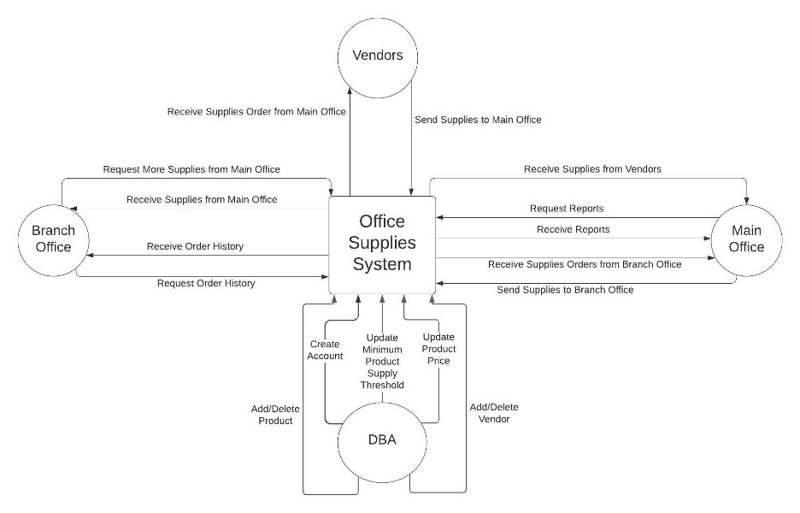

**Functional Requirements**

1. The system shall allow main office users to query an order.
2. Main office staff can generate weekly sales and shipping reports
3. Staff at the main office can approve supplies orders from a branch office and order more supplies from one of the vendors with the best price.
4. Branch office users can also request for order histories.
5. The system shall update the total number of certain supplies in the storage after getting more from vendors.
6. Administrators can add/delete products and vendors to the database

**Non-functional Requirements**

1. Availability Requirements

o The system shall be available at any time during weekdays and Saturdays.

o The system shall be offline during the system maintenance which takes place from 02:00 AM - 05:00 AM on Sundays.

2. Response Requirements

o The system shall normally respond to all user queries within 2 seconds.

o If it takes more than 2 seconds for the system to respond to a query, then the system shall inform the user of the unusual system behavior.

3. Security Requirements

o The system shall require password protected access to pages only to be viewed by the administrators

o The system shall be backed up weekly during maintenance hours: 02:00 AM - 05:00 AM on Sundays.

4. Reliability Requirements

o The system shall be fully operational at least 95% of the time.

o The down time after failure and average recovery time of the system shall not exceed five hours.

5. Scalability Requirements

o The system shall be able to handle the addition of new products, vendors, and branch offices without reengineering the system.

o The system shall be able to handle operations of said additions without reengineering the system or impacting system availability and reliability.

**Interface Requirements**

Branch Office Interface:

* Can order products from the main office by selecting a product from the list and specifying the amount needed.
  + If the amount needed isn’t available, a request is sent to the main office to order the necessary supplies from the vendor
* Can order multiple products at once by adding a product to the order list.
* Can click “Generate Report” to review a weekly history of orders, received shipments, and the current amount of each product remaining.
* Can exit the user interface by pressing “exit”

Main Office Interface:

* Can order products from the vendors with the best prices by selecting a product from the list and specifying the amount needed.
* Can order multiple products at once by adding a product to the order list.
* Can click “Generate Report” to review a weekly history of orders to vendors, shipping to branch offices, and the current amount of each product stored in the supply cabinet.
* Can exit the user interface by pressing “Exit”

Administrator Interface:

* Must enter a specified password to access the administrator interface
* Can add/delete products and vendors from the database
* Can update the price of products from a specific vendor by clicking “Update Price” and selecting the product and vendor from a menu
* Can create administrator accounts if additional administrators are required to keep the database updated.

**CONCEPTUAL DESIGN OF THE DATABASE**

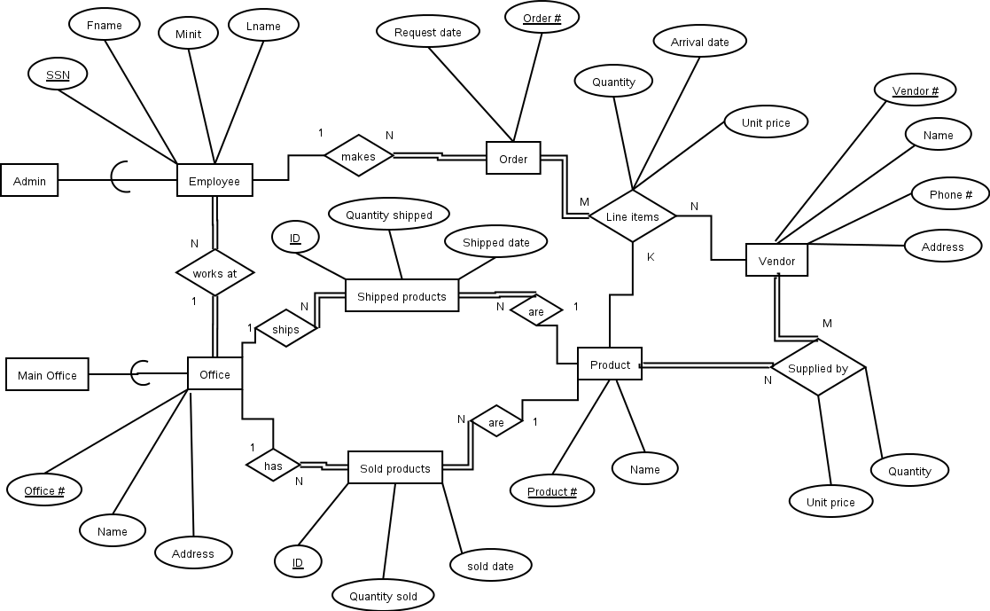

**LOGICAL DATABASE SCHEMA**

Employee(ssn, office #, Fname, Minit, Lname)

FOREIGN KEY (office #) REFERENCES Office (office #)

Administrator(ssn)

FOREIGN KEY (ssn) REFERENCES Employee (ssn)

Office(office #, name, address)

MainOffice(office #)

FOREIGN KEY (office #) REFERENCES Office (office #)

Vendor(vendor #, name, phone number, address)

Product(product #, name)

SuppliedBy(vendor #, product #, quantity available, unit price)

FOREIGN KEY (vendor #) REFERENCES Vendor (vendor #)

FOREIGN KEY (product #) REFERENCES Product (product #)

OrderPlacement(order #, ssn, request date)

FOREIGN KEY (ssn) REFERENCES Employee (ssn)

LineItems(order #, vendor #, product #, quantity, unit price, arrival date)

FOREIGN KEY (order #) REFERENCES OrderPlacement (order #)

FOREIGN KEY (product #) REFERENCES Product (product #)

FOREIGN KEY (vendor #) REFERENCES Vendor (vendor #)

Shipped(id, office #, product #, quantity shipped, shipped date)

FOREIGN KEY (office #) REFERENCES Office (office #)

FOREIGN KEY (product #) REFERENCES Product (product #)

sold(id, office #, product #, quantitySold, soldDate)

FOREIGN KEY (office #) REFERENCES Office (office #)

FOREIGN KEY (product #) REFERENCES Product (product #)

**Database Construction:**

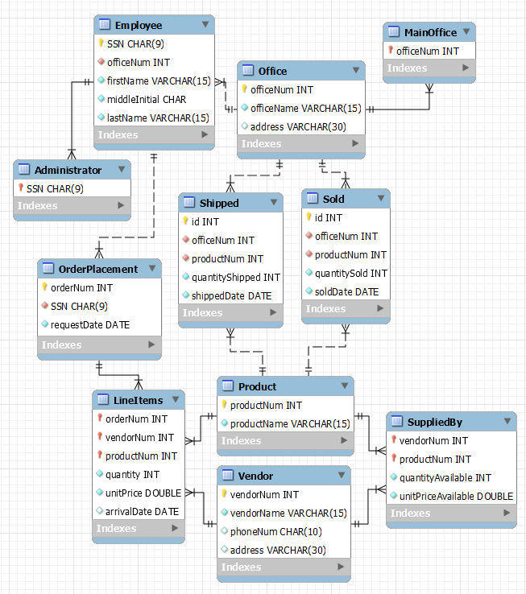

**-- -----------------------------------------------------**

**-- Table `Office`**

**-- -----------------------------------------------------**

**CREATE TABLE IF NOT EXISTS `Office` (**

**`officeNum` INT NOT NULL AUTO_INCREMENT,**

**`officeName` VARCHAR(15) NOT NULL,**

**`address` VARCHAR(30) NULL DEFAULT NULL,**

**PRIMARY KEY (`officeNum`));**

**-- -----------------------------------------------------**

**-- Table `MainOffice`**

**-- -----------------------------------------------------**

**CREATE TABLE IF NOT EXISTS `MainOffice` (**

**`officeNum` INT NOT NULL,**

**PRIMARY KEY (`officeNum`),**

**CONSTRAINT ``**

**FOREIGN KEY (`officeNum`)**

**REFERENCES `Office` (`officeNum`));**

**-- -----------------------------------------------------**

**-- Table `Employee`**

**-- -----------------------------------------------------**

**CREATE TABLE IF NOT EXISTS `Employee` (**

**`SSN` CHAR(9) NOT NULL,**

**`officeNum` INT NOT NULL,**

**`firstName` VARCHAR(15) NOT NULL,**

**`middleInitial` CHAR NOT NULL,**

**`lastName` VARCHAR(15) NOT NULL,**

**PRIMARY KEY (`SSN`),**

**CONSTRAINT ``**

**FOREIGN KEY (`officeNum`)**

**REFERENCES `Office` (`officeNum`));**

**-- -----------------------------------------------------**

**-- Table `Administrator`**

**-- -----------------------------------------------------**

**CREATE TABLE IF NOT EXISTS `Administrator` (**

**`SSN` CHAR(9) NOT NULL,**

**PRIMARY KEY (`SSN`),**

**CONSTRAINT ``**

**FOREIGN KEY (`SSN`)**

**REFERENCES `Employee` (`SSN`));**

**-- -----------------------------------------------------**

**-- Table `Vendor`**

**-- -----------------------------------------------------**

**CREATE TABLE IF NOT EXISTS `Vendor` (**

**`vendorNum` INT NOT NULL AUTO_INCREMENT,**

**`vendorName` VARCHAR(15) NOT NULL,**

**`phoneNum` CHAR(10) NULL DEFAULT NULL,**

**`address` VARCHAR(30) NULL DEFAULT NULL,**

**PRIMARY KEY (`vendorNum`));**

**-- -----------------------------------------------------**

**-- Table `Product`**

**-- -----------------------------------------------------**

**CREATE TABLE IF NOT EXISTS `Product` (**

**`productNum` INT NOT NULL AUTO_INCREMENT,**

**`productName` VARCHAR(15) NOT NULL,**

**PRIMARY KEY (`productNum`));**

**-- -----------------------------------------------------**

**-- Table `SuppliedBy`**

**-- -----------------------------------------------------**

**CREATE TABLE IF NOT EXISTS `SuppliedBy` (**

**`vendorNum` INT NOT NULL,**

**`productNum` INT NOT NULL,**

**`quantityAvailable` INT NOT NULL,**

**`unitPriceAvailable` DOUBLE NOT NULL,**

**PRIMARY KEY (`vendorNum`, `productNum`),**

**CONSTRAINT ``**

**FOREIGN KEY (`vendorNum`)**

**REFERENCES `Vendor` (`vendorNum`),**

**CONSTRAINT ``**

**FOREIGN KEY (`productNum`)**

**REFERENCES `Product` (`productNum`));**

**-- -----------------------------------------------------**

**-- Table `OrderPlacement`**

**-- -----------------------------------------------------**

**CREATE TABLE IF NOT EXISTS `OrderPlacement` (**

**`orderNum` INT NOT NULL AUTO_INCREMENT,**

**`SSN` CHAR(9) NOT NULL,**

**`requestDate` DATE NOT NULL,**

**PRIMARY KEY (`orderNum`),**

**CONSTRAINT `fk_orderPlacement_employee1`**

**FOREIGN KEY (`SSN`)**

**REFERENCES `Employee` (`SSN`)**

**ON DELETE NO ACTION**

**ON UPDATE NO ACTION);**

**-- -----------------------------------------------------**

**-- Table `LineItems`**

**-- -----------------------------------------------------**

**CREATE TABLE IF NOT EXISTS `LineItems` (**

**`orderNum` INT NOT NULL,**

**`vendorNum` INT NOT NULL,**

**`productNum` INT NOT NULL,**

**`quantity` INT NOT NULL,**

**`unitPrice` DOUBLE NOT NULL,**

**`arrivalDate` DATE NULL,**

**PRIMARY KEY (`orderNum`, `vendorNum`, `productNum`),**

**CONSTRAINT `fk_table1_orderInfo1`**

**FOREIGN KEY (`orderNum`)**

**REFERENCES `OrderPlacement` (`orderNum`)**

**ON DELETE NO ACTION**

**ON UPDATE NO ACTION,**

**CONSTRAINT `fk_LineItems_product1`**

**FOREIGN KEY (`productNum`)**

**REFERENCES `Product` (`productNum`)**

**ON DELETE NO ACTION**

**ON UPDATE NO ACTION,**

**CONSTRAINT `fk_LineItems_Vendor1`**

**FOREIGN KEY (`vendorNum`)**

**REFERENCES `Vendor` (`vendorNum`)**

**ON DELETE NO ACTION**

**ON UPDATE NO ACTION);**

**-- -----------------------------------------------------**

**-- Table `Shipped`**

**-- -----------------------------------------------------**

**CREATE TABLE IF NOT EXISTS `Shipped` (**

**`id` INT NOT NULL AUTO_INCREMENT,**

**`officeNum` INT NOT NULL,**

**`productNum` INT NOT NULL,**

**`quantityShipped` INT NOT NULL,**

**`shippedDate` DATE NOT NULL,**

**PRIMARY KEY (`id`),**

**CONSTRAINT `fk_Shipped_Office1`**

**FOREIGN KEY (`officeNum`)**

**REFERENCES `Office` (`officeNum`)**

**ON DELETE NO ACTION**

**ON UPDATE NO ACTION,**

**CONSTRAINT `fk_Shipped_Product1`**

**FOREIGN KEY (`productNum`)**

**REFERENCES `Product` (`productNum`)**

**ON DELETE NO ACTION**

**ON UPDATE NO ACTION);**

**-- -----------------------------------------------------**

**-- Table `Sold`**

**-- -----------------------------------------------------**

**CREATE TABLE IF NOT EXISTS `Sold` (**

**`id` INT NOT NULL AUTO_INCREMENT,**

**`officeNum` INT NOT NULL,**

**`productNum` INT NOT NULL,**

**`quantitySold` INT NOT NULL,**

**`soldDate` DATE NOT NULL,**

**PRIMARY KEY (`id`),**

**CONSTRAINT `fk_Sold_Office1`**

**FOREIGN KEY (`officeNum`)**

**REFERENCES `Office` (`officeNum`)**

**ON DELETE NO ACTION**

**ON UPDATE NO ACTION,**

**CONSTRAINT `fk_Sold_Product1`**

**FOREIGN KEY (`productNum`)**

**REFERENCES `Product` (`productNum`)**

**ON DELETE NO ACTION**

**ON UPDATE NO ACTION);**

**FUNCTIONAL DEPENDENCIES AND DATABASE NORMALIZATION**

Employee(ssn, office #, Fname, Minit, Lname)

* ssn → office #, Fname, Minit, Lname

Administrator(ssn)

Office(office #, name, address)

* office # → name, address

Main Office(office #)

Vendor(vendor #, name, phone number, address)

* vendor # → name, phone number, address

Product(product #, name)

* product # → Name

supplied_by(vendor #, product #, quantity available, unit price)

* vendor #, product # → quantity available, unit price

OrderPlacement(order #, ssn, request date)

* Order # → ssn, request date

LineItems(order #, vendor #, product #, quantity, unit price, arrival date)

* Order #, vendor #, product # → quantity, unit price, arrival date

Shipped(id, office #, product #, quantity shipped, shipped date)

* Id → office #, product #, quantity shipped, shipped date

sold(id, office #, product #, quantitySold, soldDate)

* Id → office #, product #, quantitySold, soldDate

**Database Normalization**

The schemas of the database are already in 1NF. As there are no partial key dependencies, the above schema is already in 2NF. Additionally, as there are no transitive dependencies, the above schema is already in 3NF. Therefore, there is no need to normalize the tables further.

**THE DATABASE SYSTEM**

Download MySQL at:

<https://dev.mysql.com/downloads/installer/>

**Installation guide:**

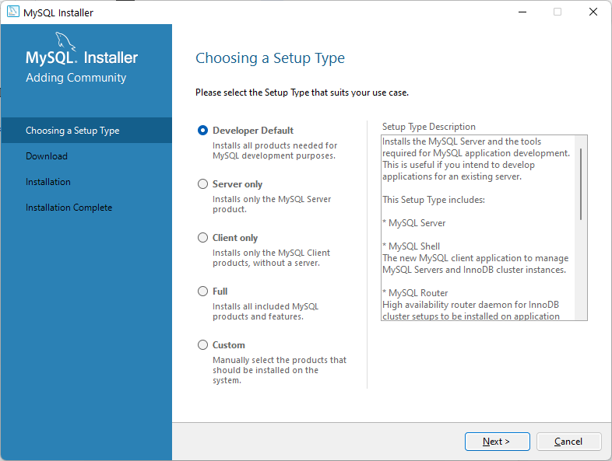

Choose next

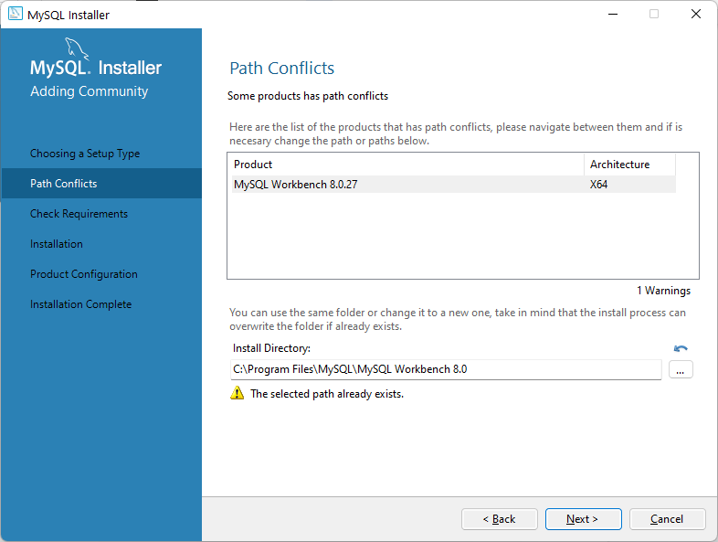

Choose yes if there is a warning message and then choose next

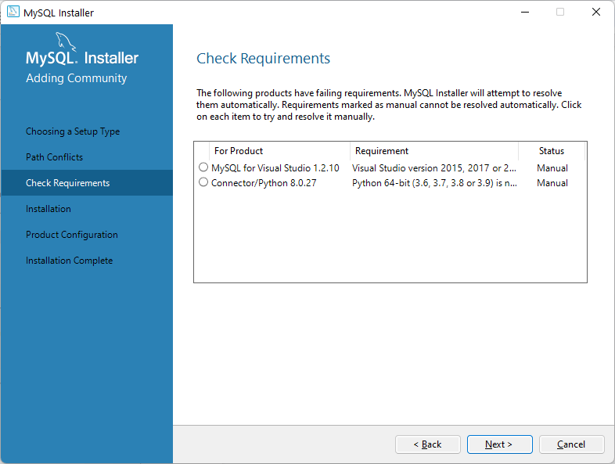

Choose next and ignore the message

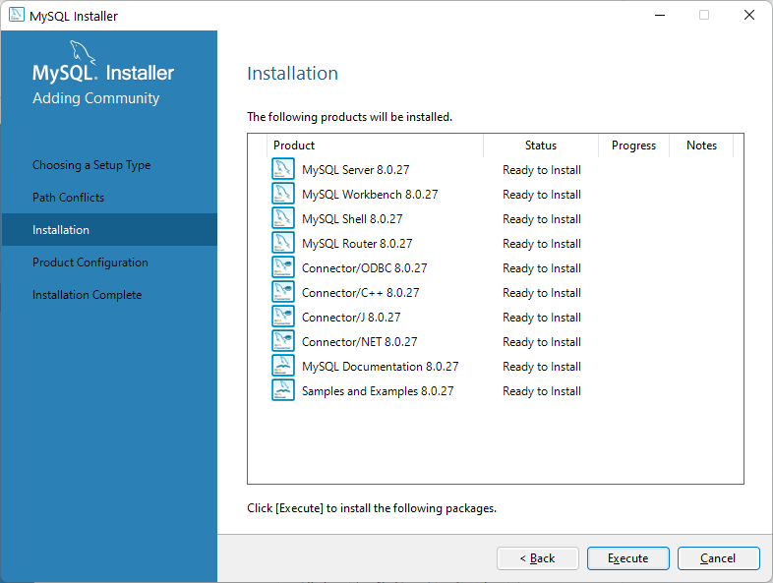

Click execute and wait for the installation process to finish

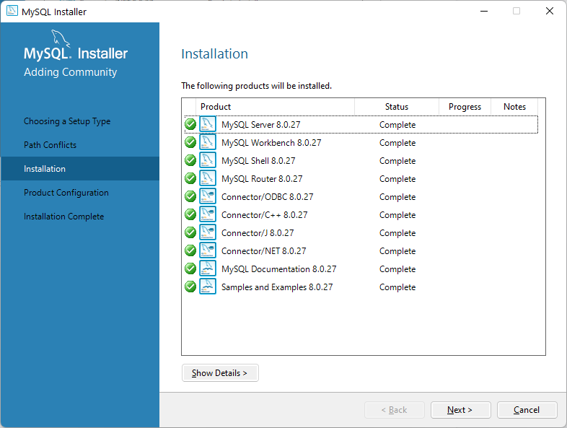

Choose next

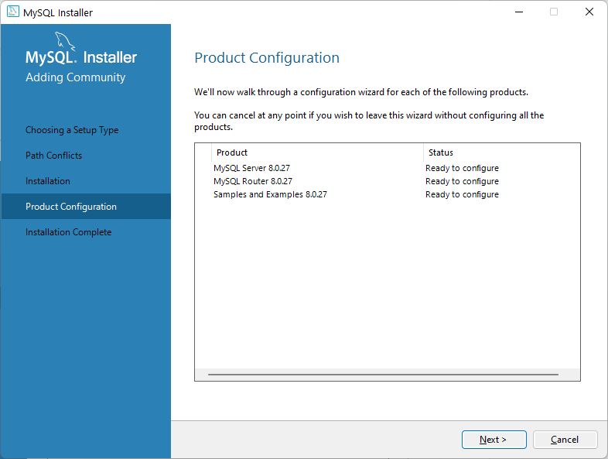

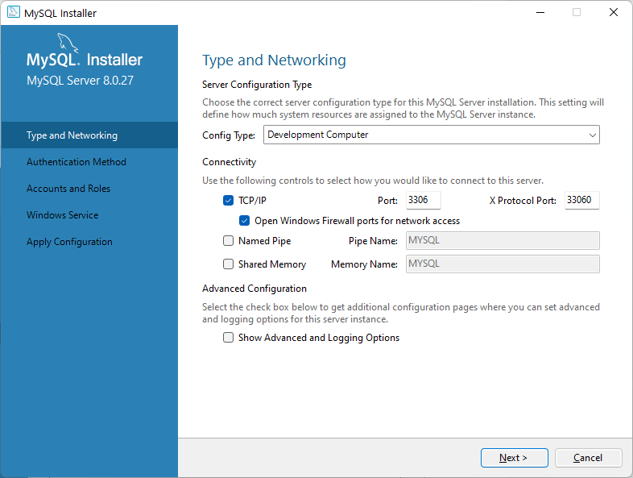

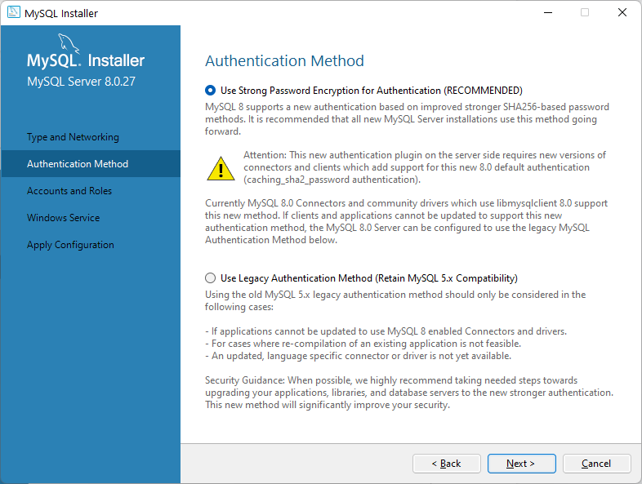

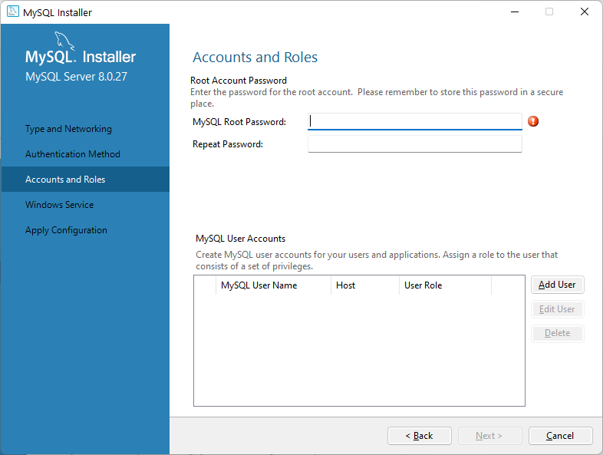

Put root for both fields and then choose next

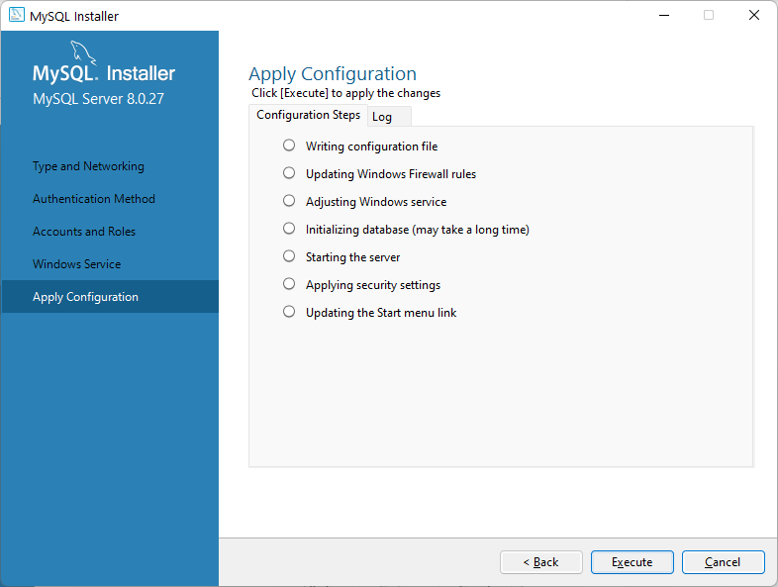

Choose execute and wait for the installing to finish

Choose next until see the finish button

Then choose finish

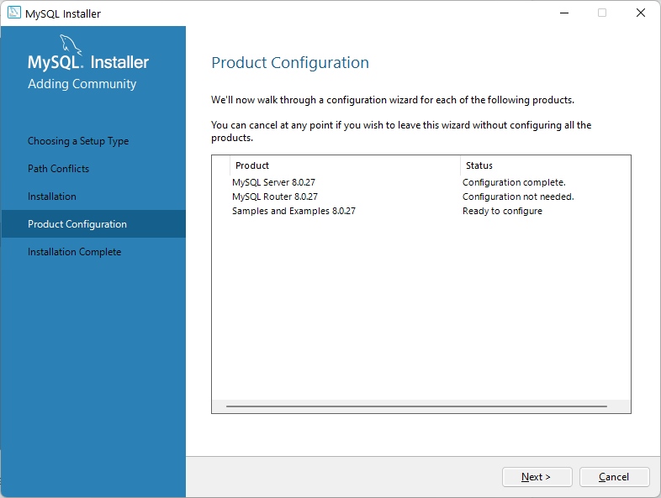

Choose next

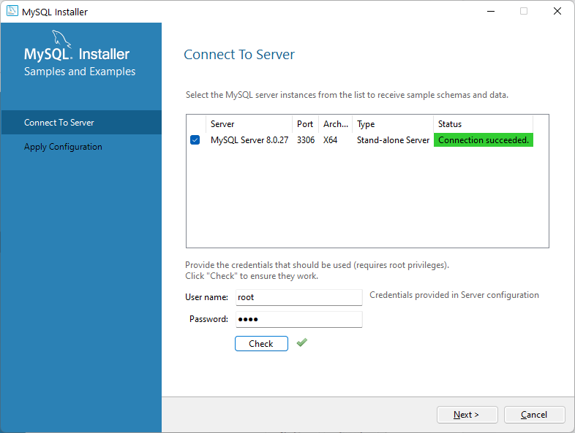Enter your password and hit check, then next

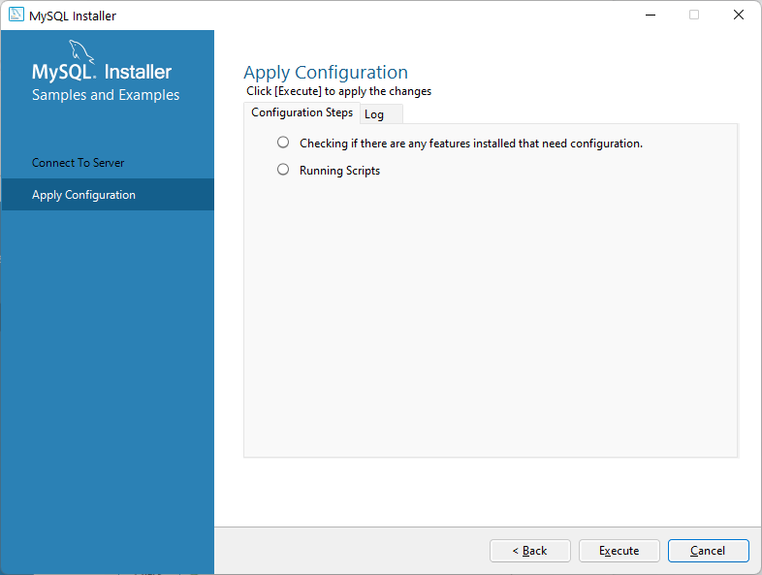

Choose execute and wait, and then choose finish

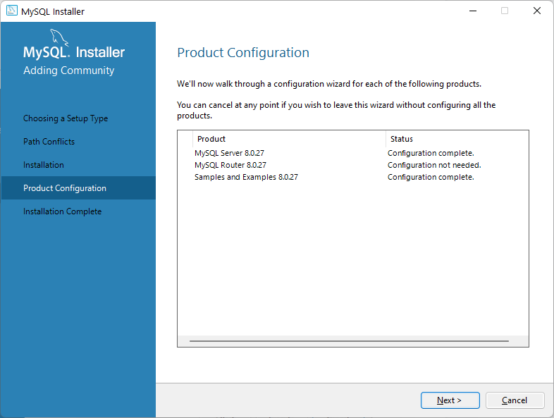

Choose next

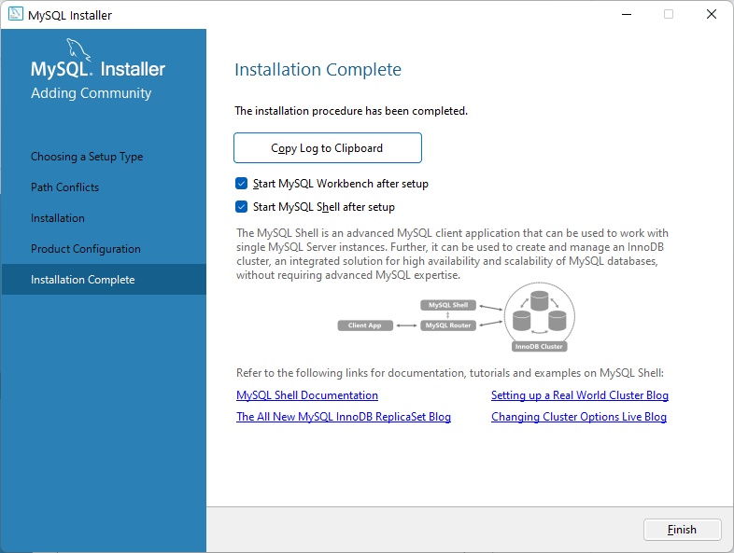

And then finish

Close the command line instance and use the GUI one

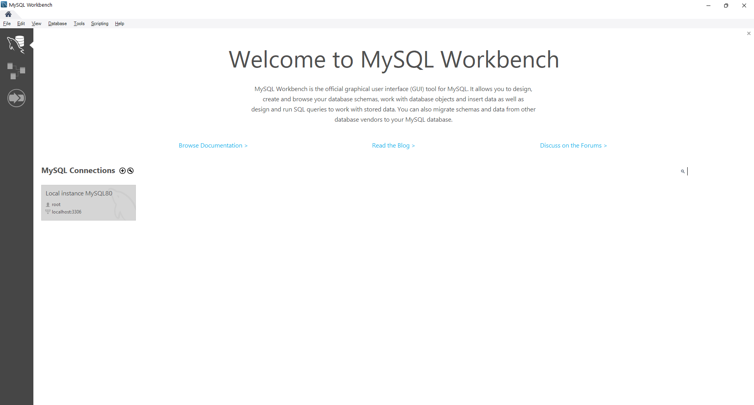

Click/double click on the local instance

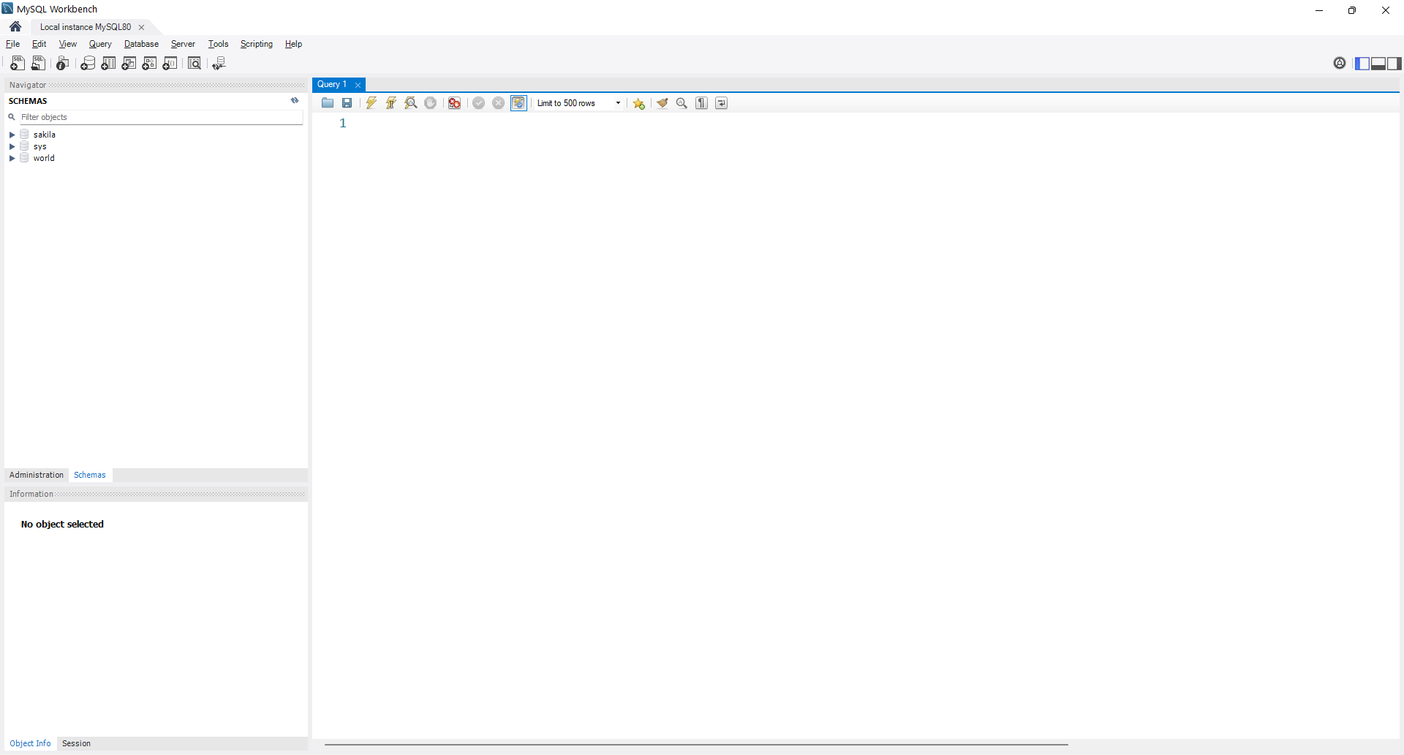

Go to file, then open SQL script

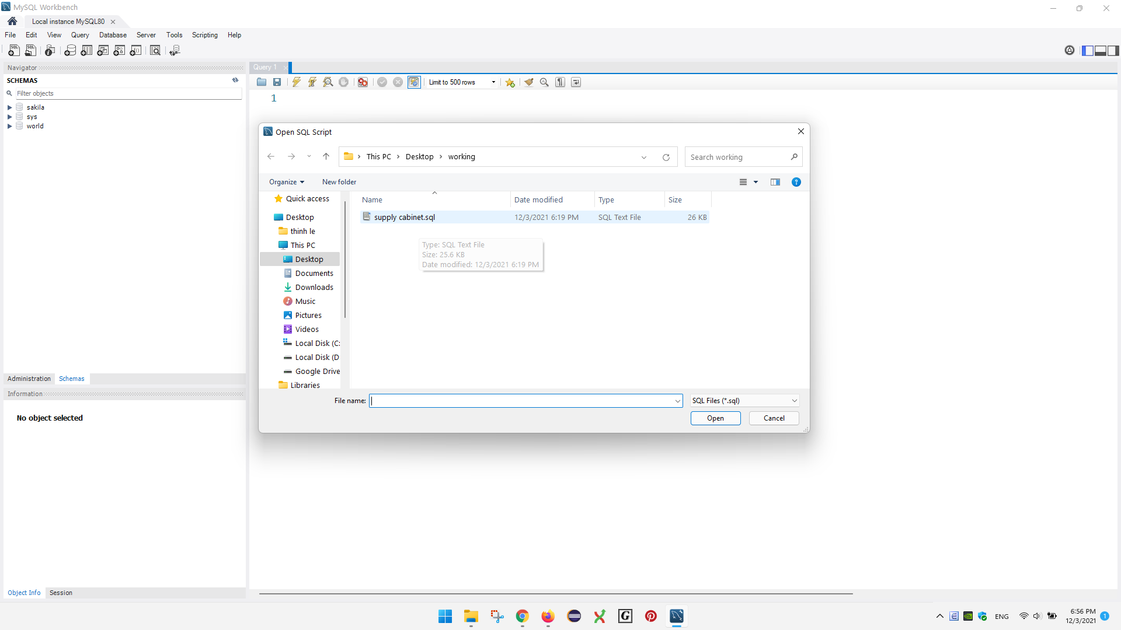

Open the supply cabinet.sql file

It should look like this:

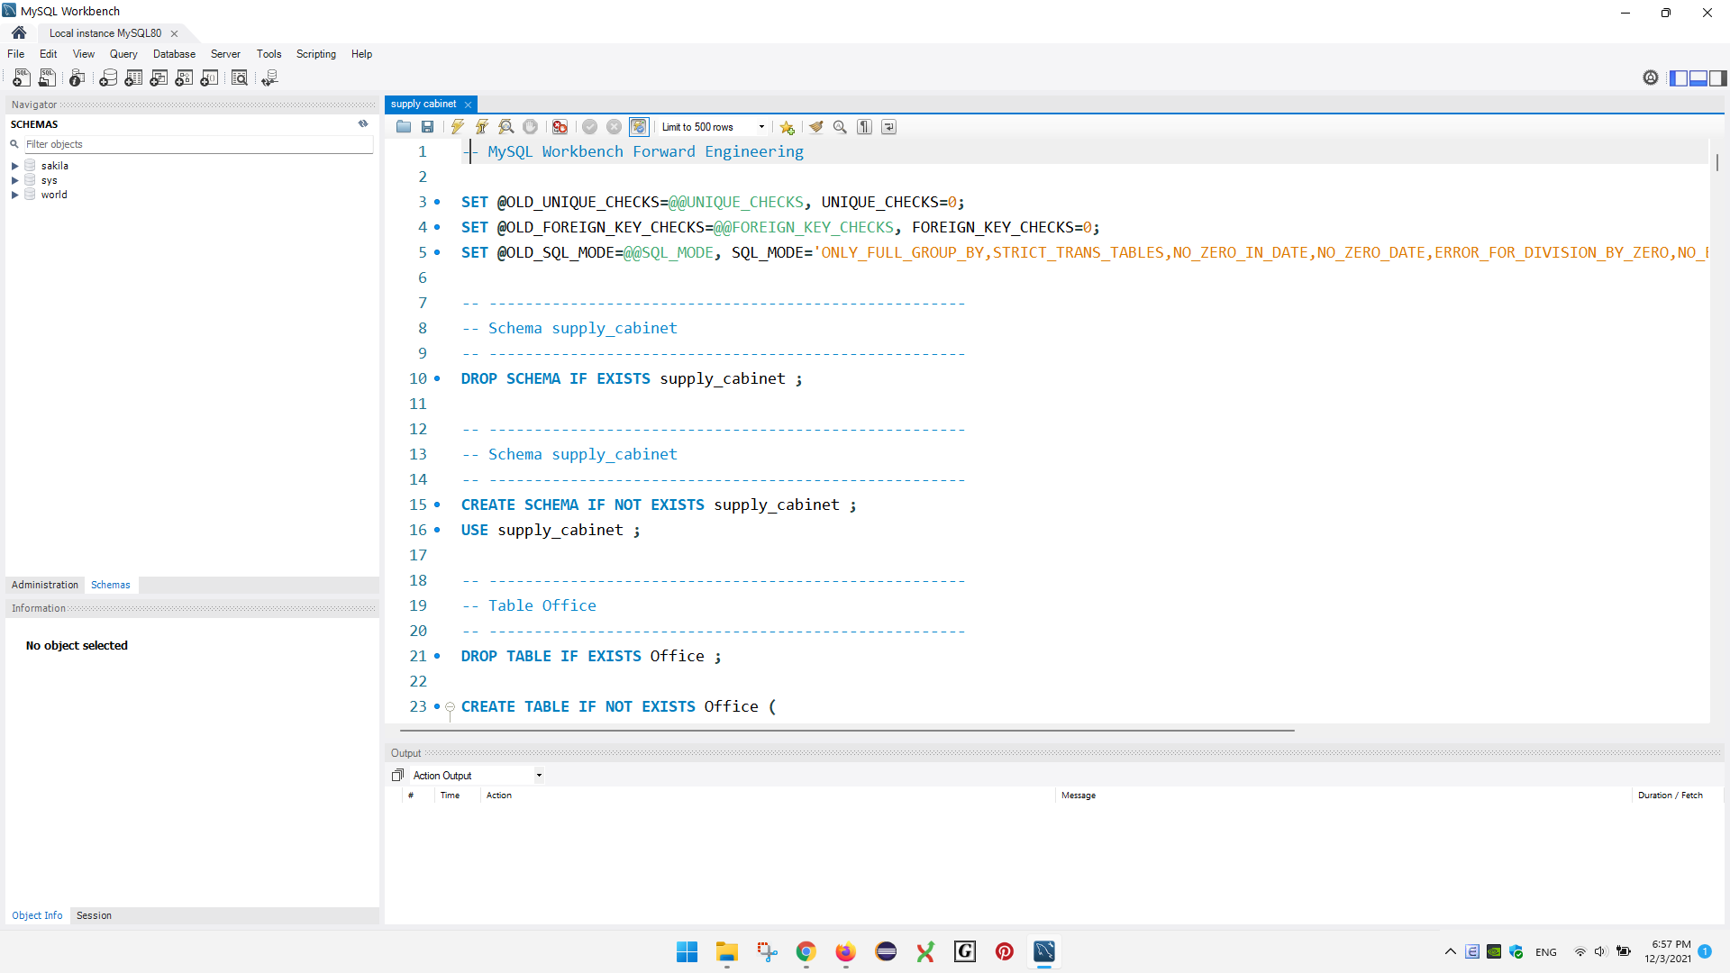

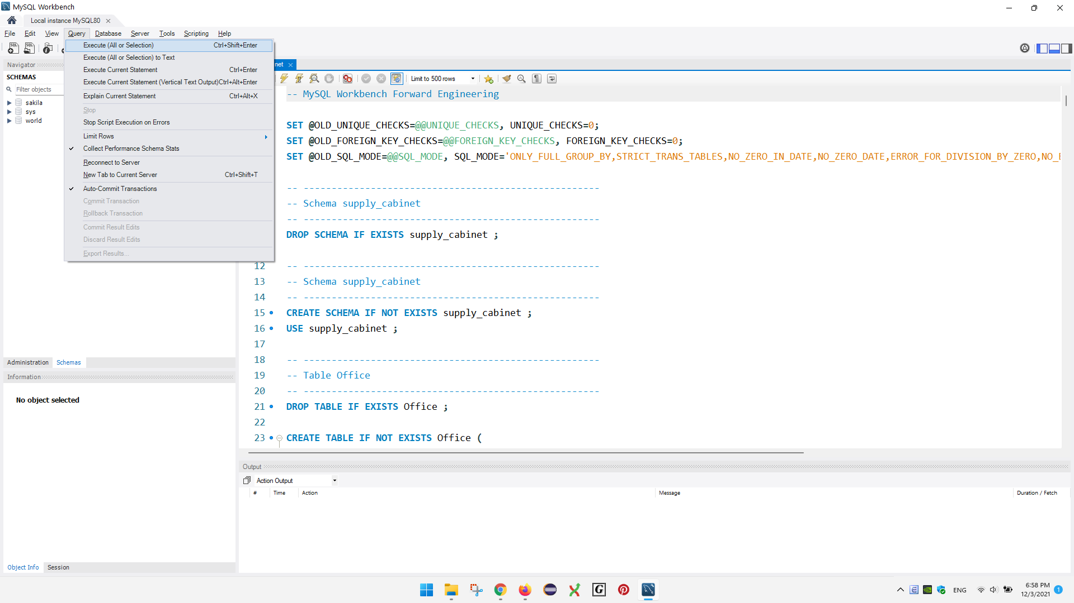

Go to Query, then choose execute all or selection

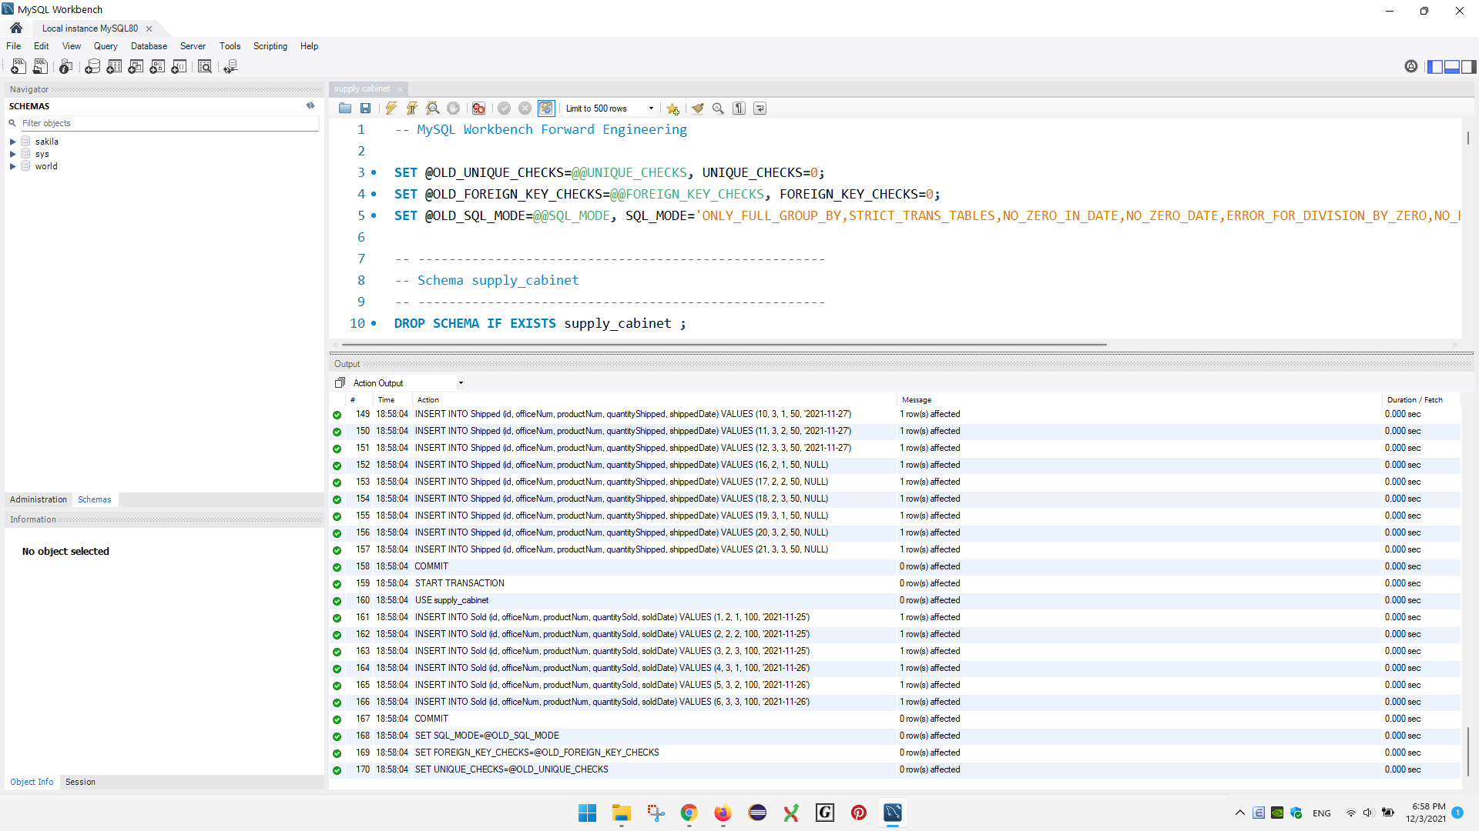

Notice that commands should be executed, or there is no errors shown

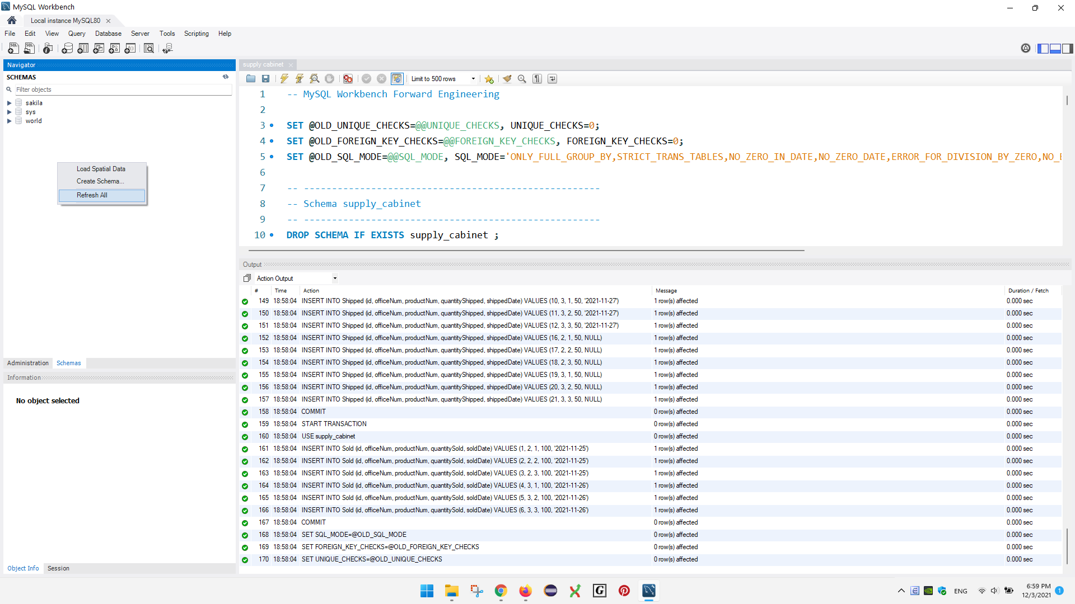

Right click on the navigator panel which should locate to the left side of the screen, then choose refresh all

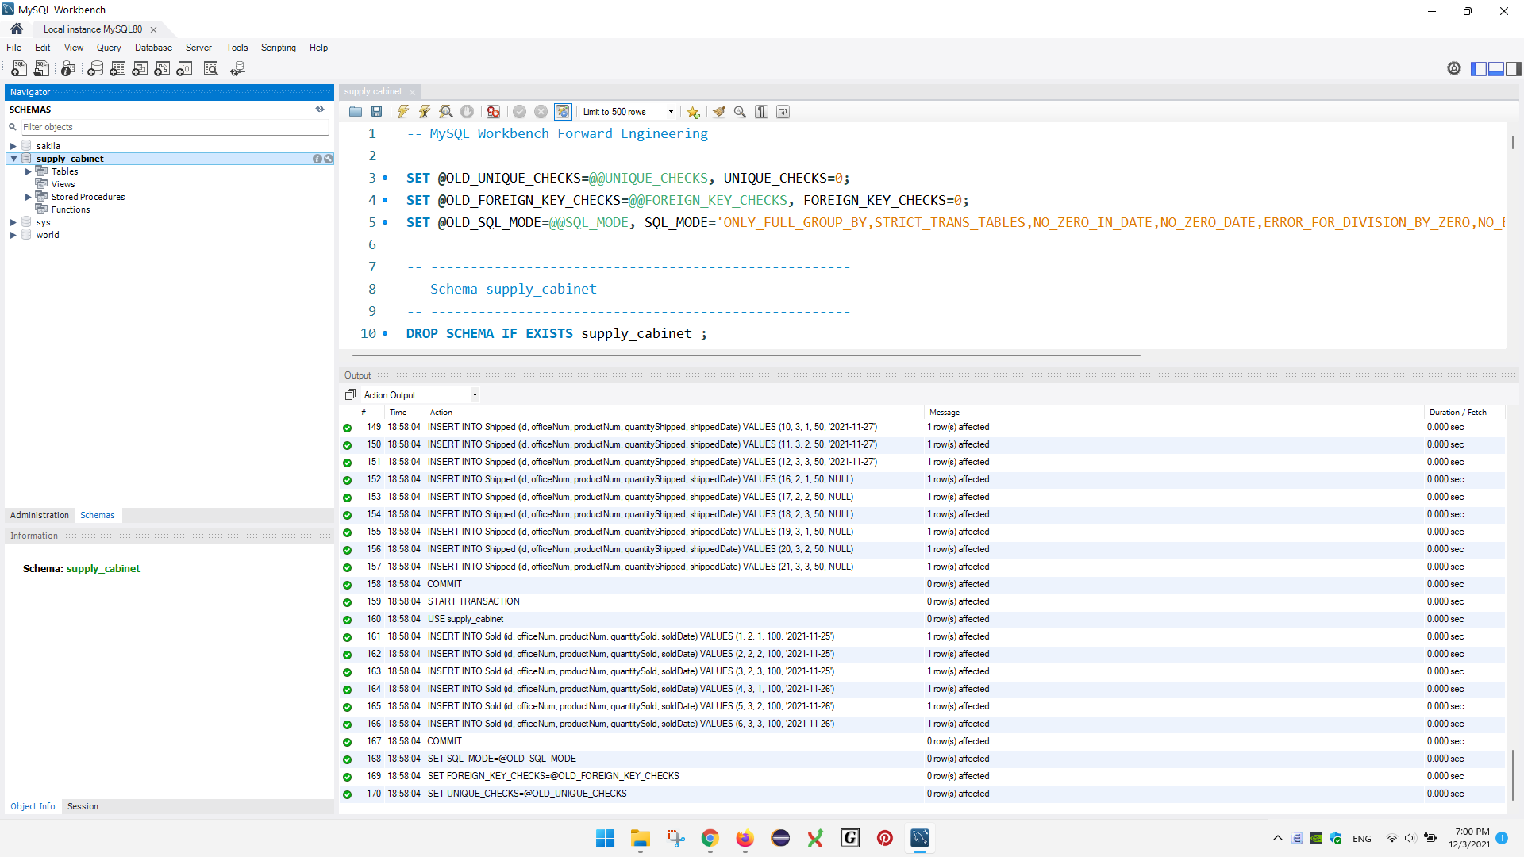

By now, there should be a database named supply cabinet as shown in the picture above

Download Eclipse EE (not the SE version)

<https://www.eclipse.org/downloads/>

**Installation guide:**

Run the downloaded installer

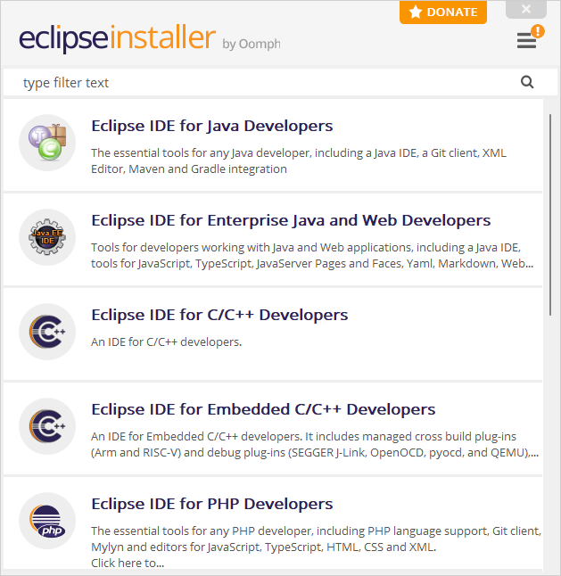

Choose Eclipse IDE for Enterprise Java and Web Developers (the second option)

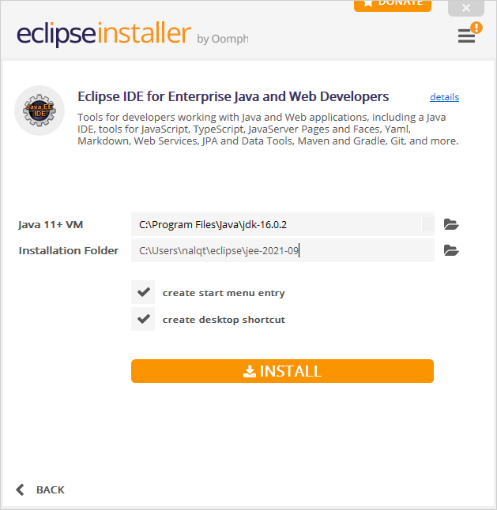

Then choose the location where you would like to install the IDE and wait for the installing process to finish. After that, run the IDE.

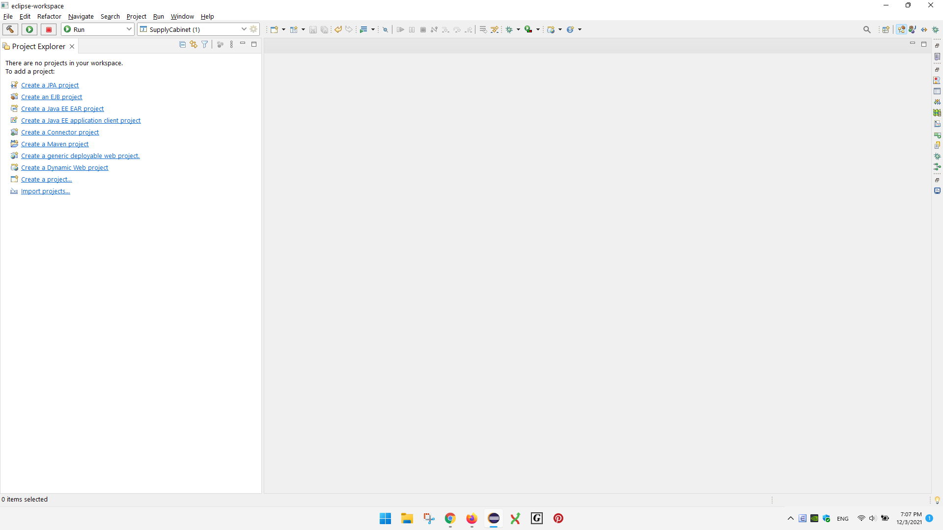

It should look like the above picture

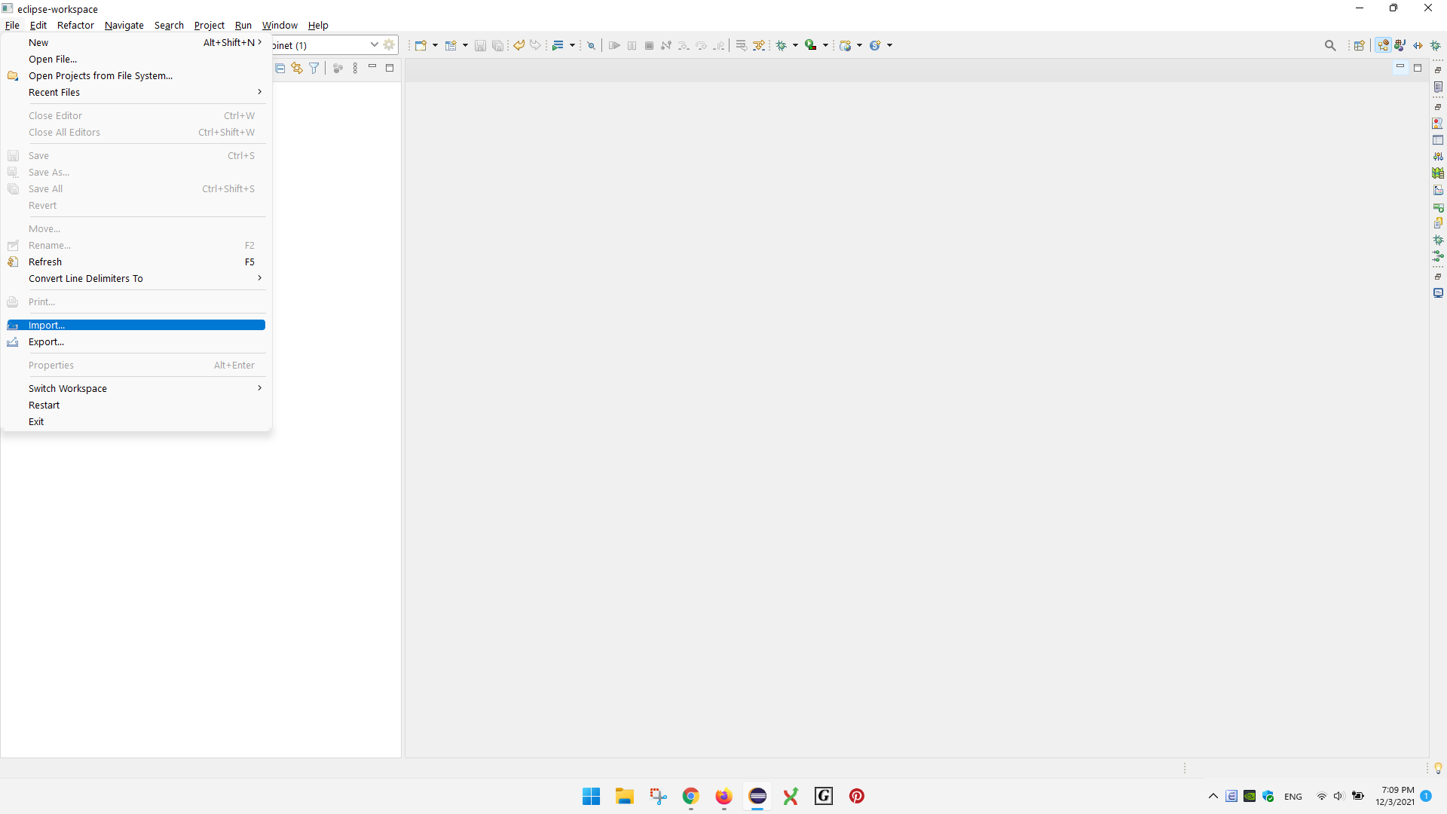

Go to file, and then choose import

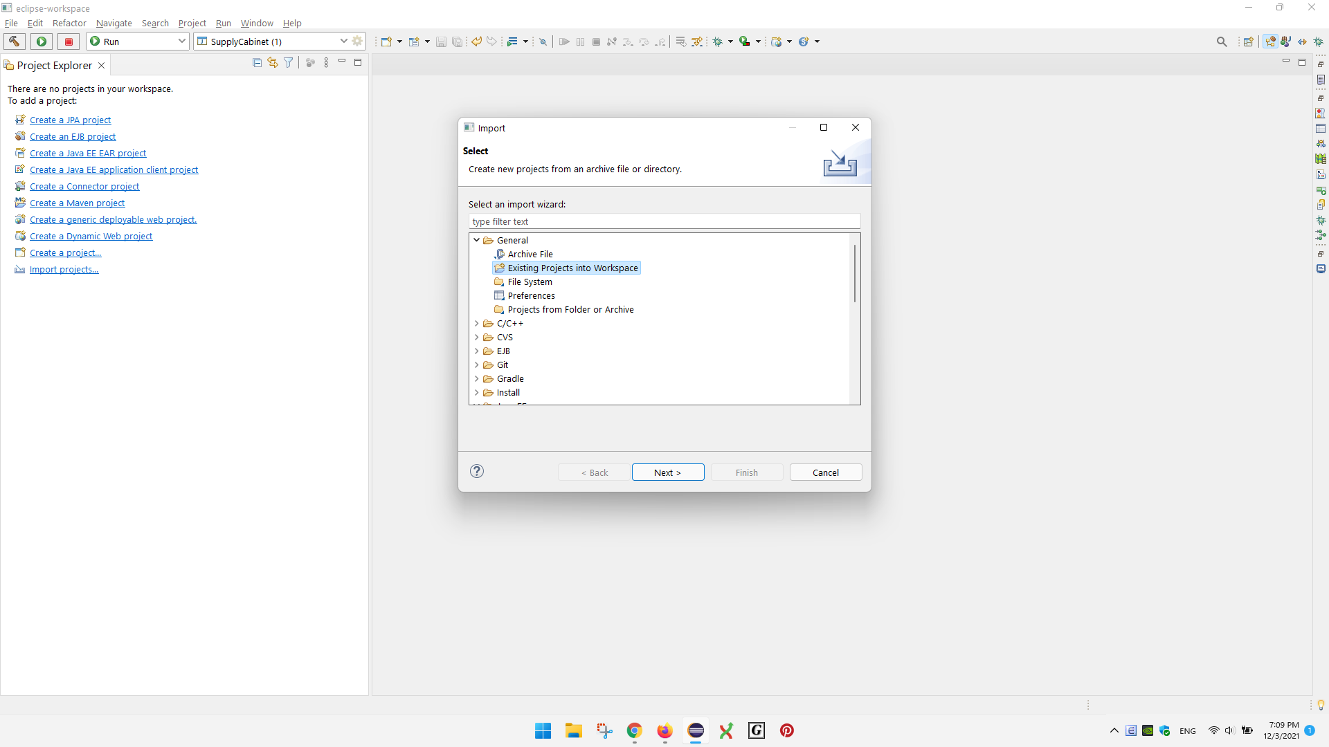

Choose existing projects into workspace

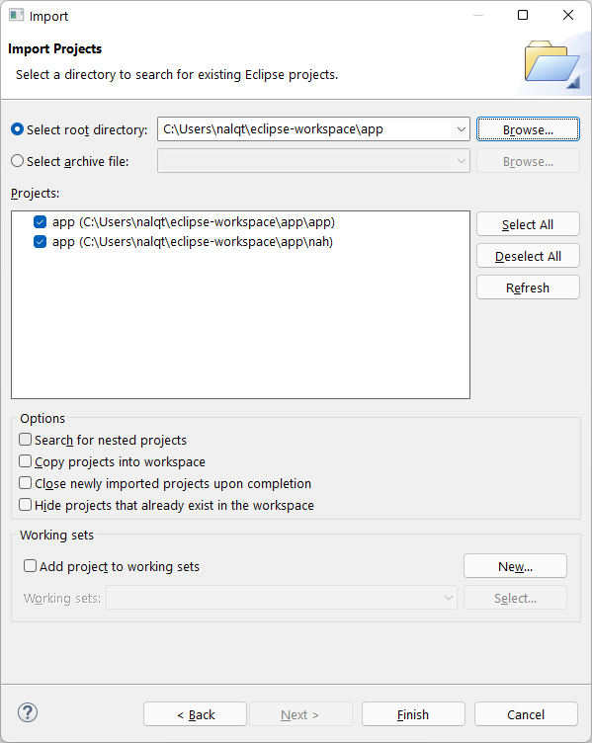

Choose browse

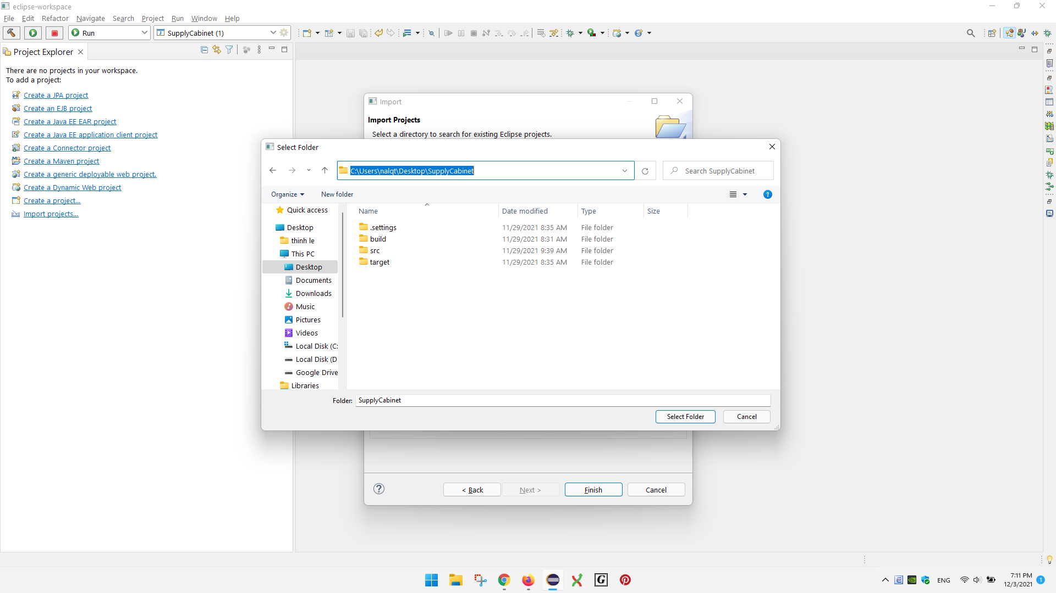

Go to the SupplyCabinet folder (folder containing the source code for the program), and then choose select folder

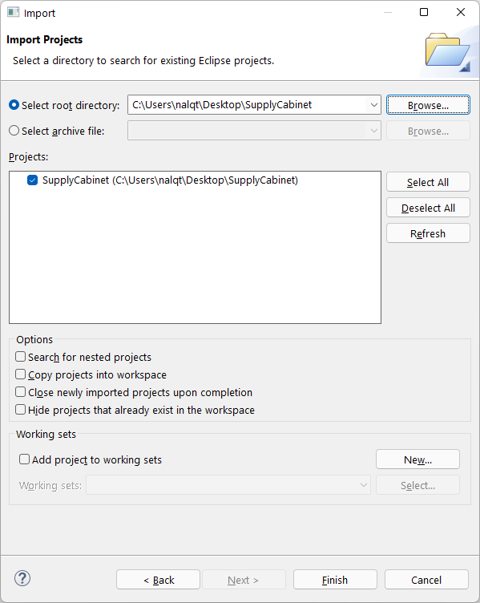

Choose finish

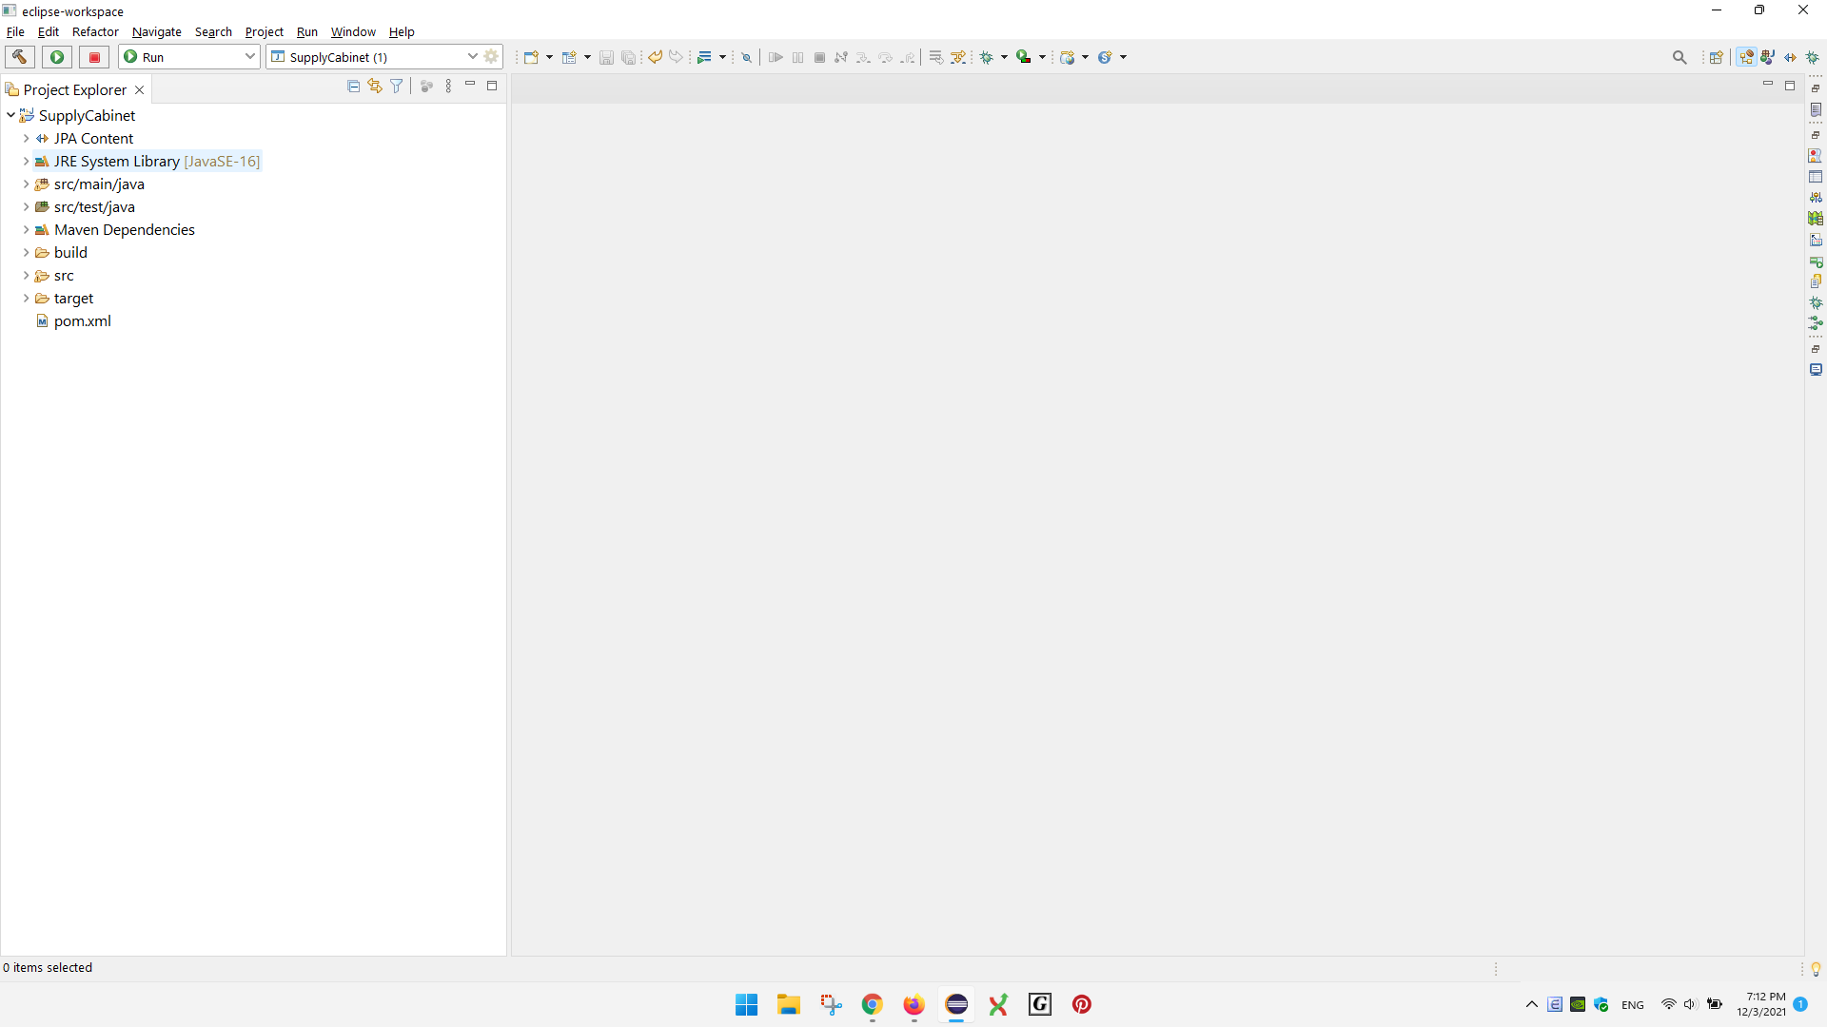

It may show that there are errors in some of the source code files.

Wait for a moment (5 to 10 seconds) and it should disappear

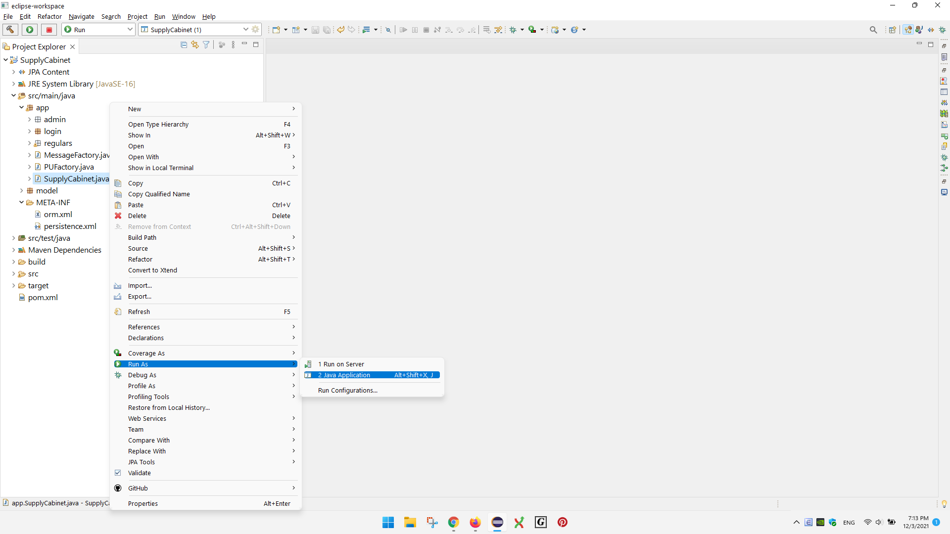

Run the SupplyCabinet.Java file

Right click on that file, choose the Run as option, then choose “java application”

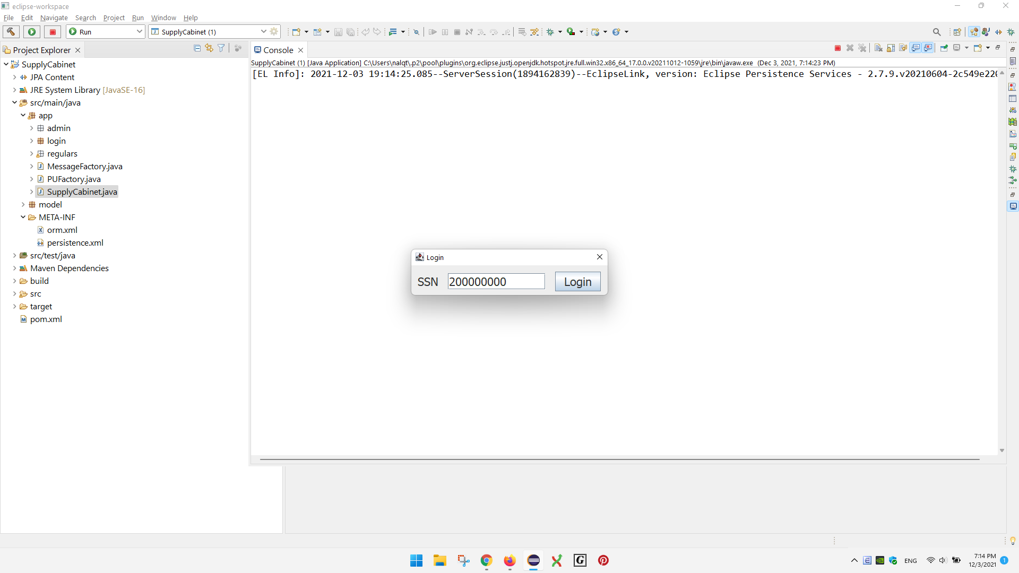

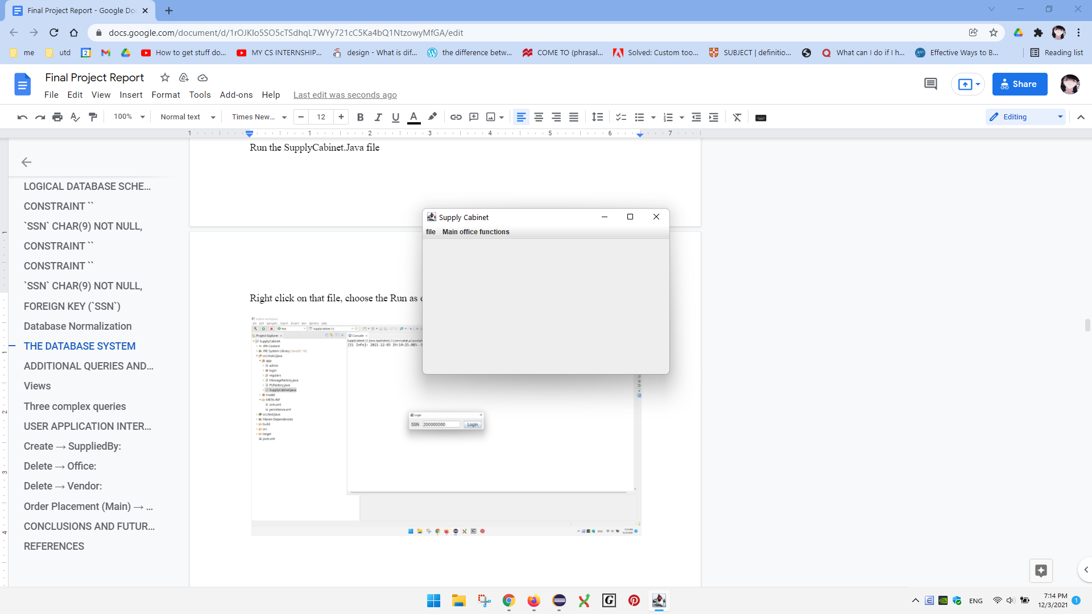

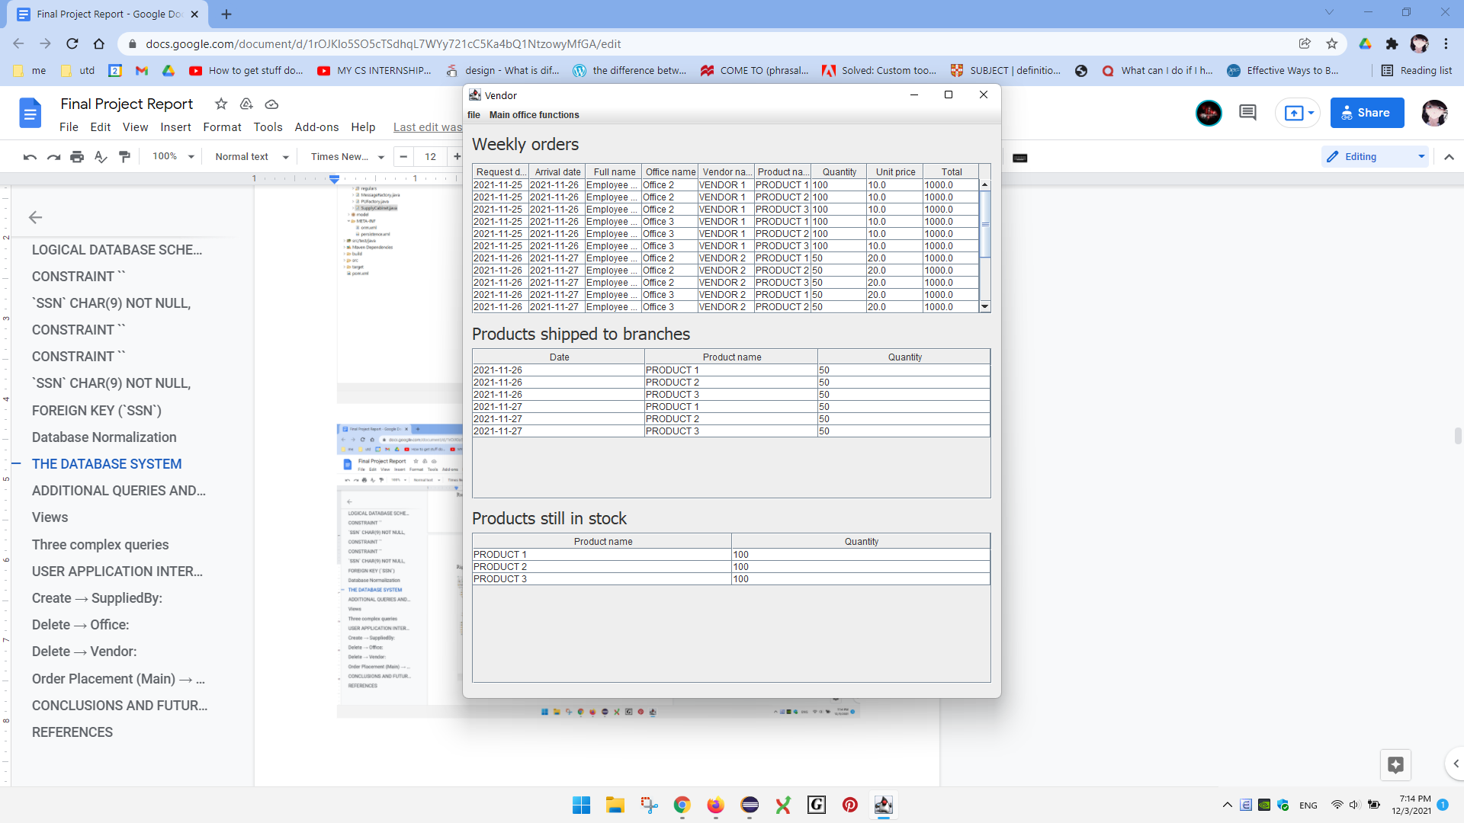

**ADDITIONAL QUERIES AND VIEWS**

**1st Complex Query**: Produce the in-stock product report (branch office).

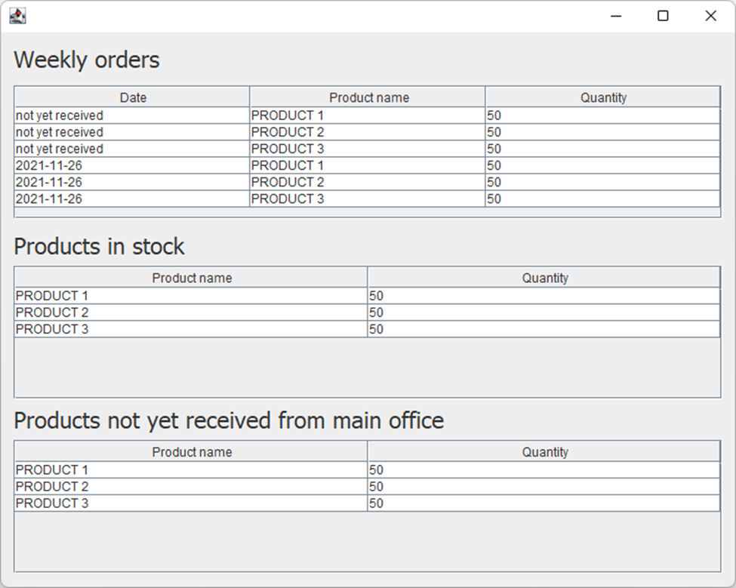

Data in the Shipped table:

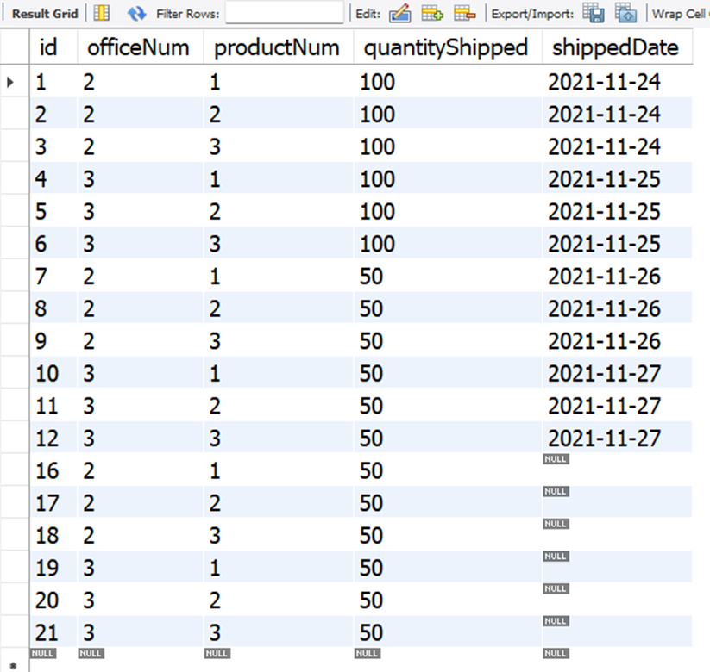

Data in the Sold table:

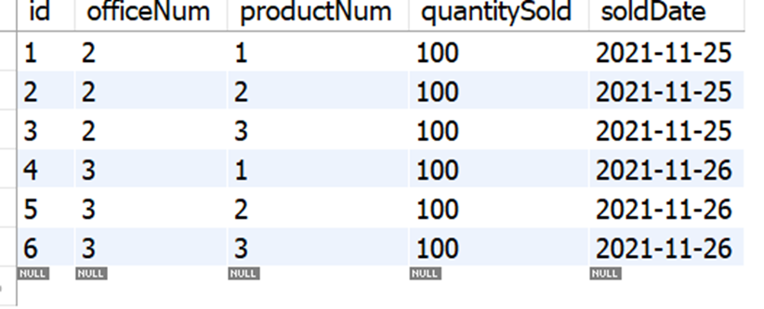

The Shipped table has the information on the number of products having been shipped to a branch or in stock at a particular branch (total amount). The Sold table stores the quantity of products that have been sold or no longer in the branch storage (sold amount). To find the quantity in stock at a branch office storage, we subtract the quantity in the Shipped table to the one in the Sold table (total – sold = remaining).

The query will first find all products that are currently in stock at a specific branch (shippedDate is not null). Next, it will group the products based on the product number. Then, it will find the total quantity of the products in each group.

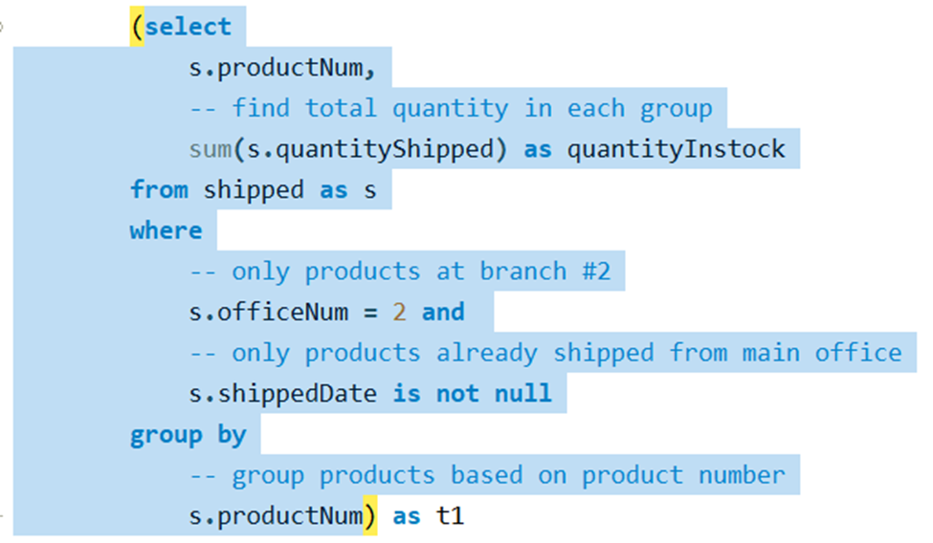

Result: In stock quantity at branch #2

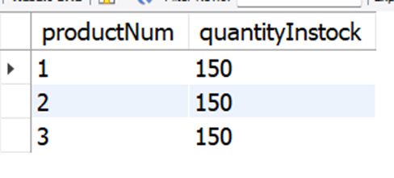

Similarly, it will find all products sold at the branch, group the products, and then find the total quantity in each group.

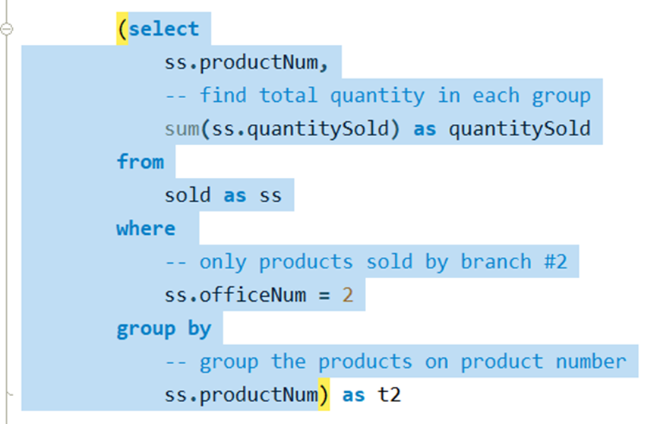

Result: quantity sold at branch #2

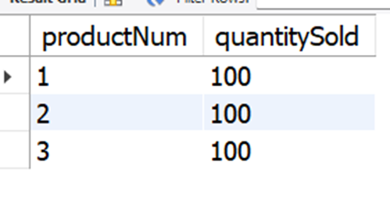

Next, the query will join these two tables to find the remaining quantity in stock at the main office. The product number is used to merge the two tables.

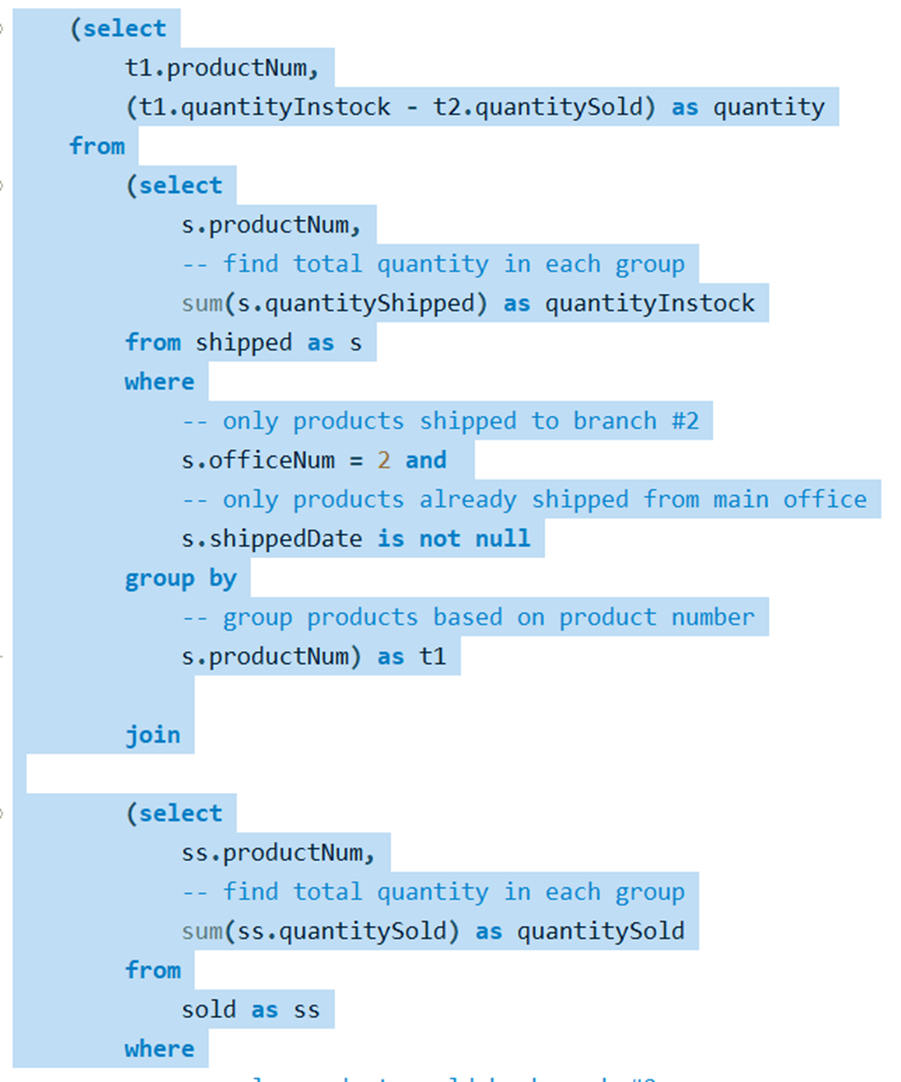

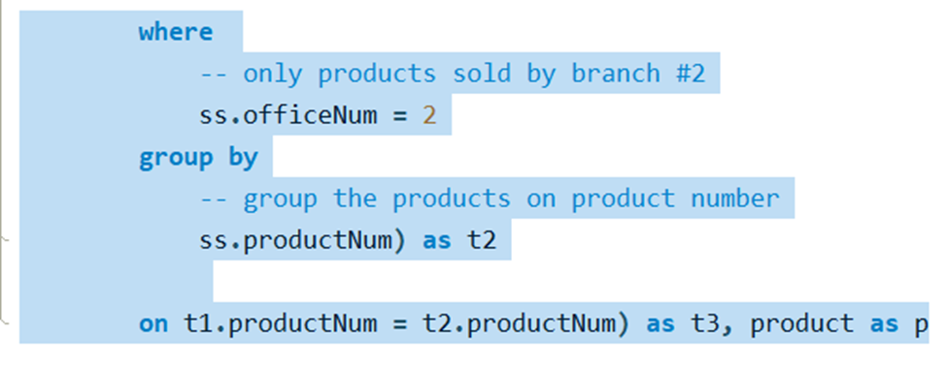

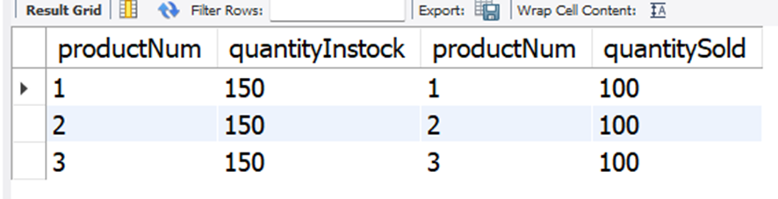

From this table, we can easily find the remaining quantity by subtracting the value in the quantityInstock column by the value in the quantitySold column.

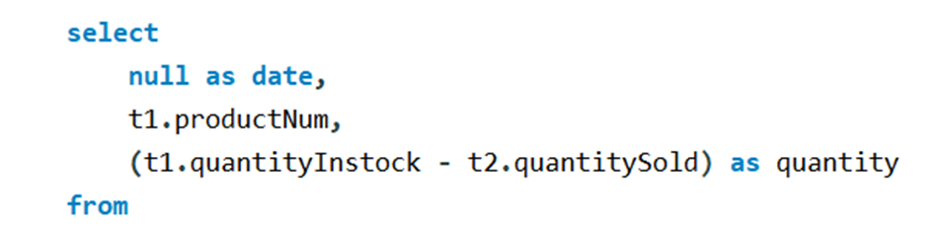

(The rest of the SQL is the same)

However, the user is only interested in the product name and the quantity remaining. Therefore, the query will remove the irrelevant information from the table above and add other significant information to the final result.

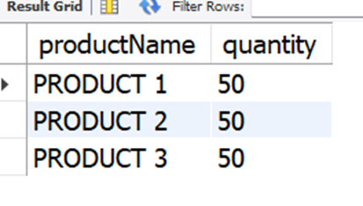

Complete SQL:

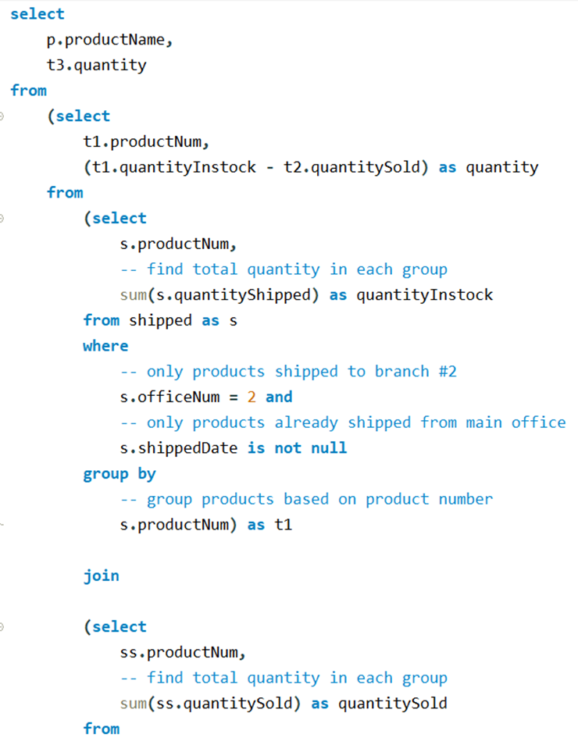

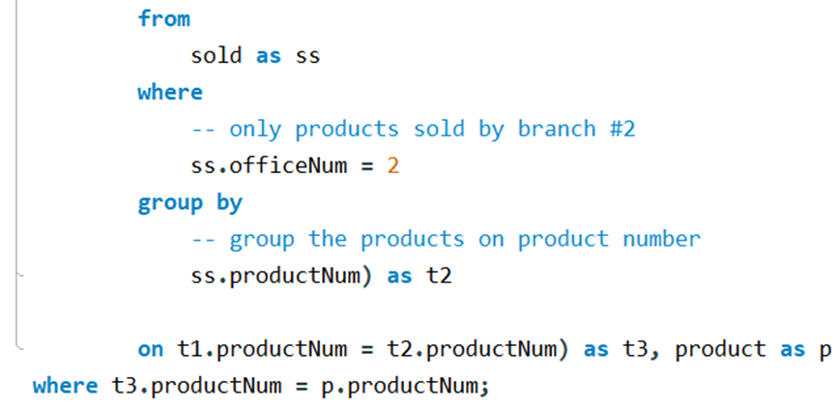

**2nd Complex Query**: generate the in-stock product report (main office), i.e., the query will find all the products remaining in stock at the main office.

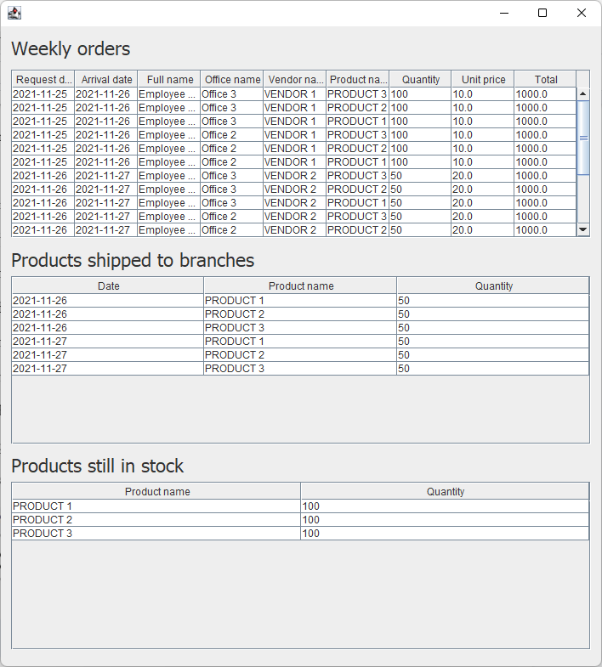

Data in the LineItems table:

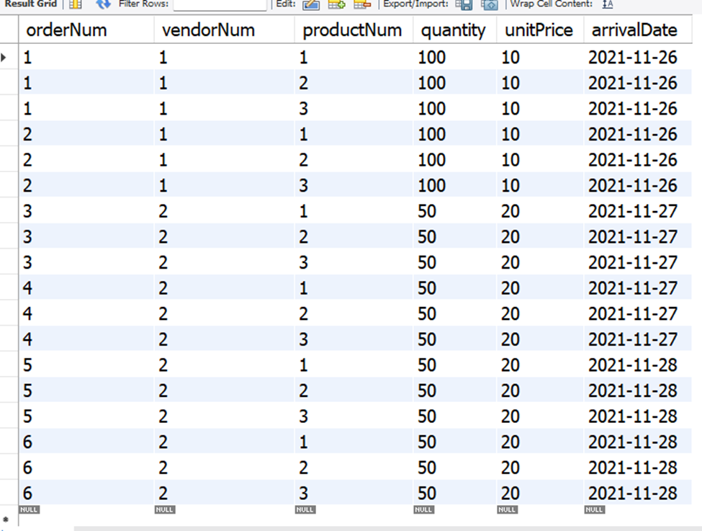

Data in the Shipped table:

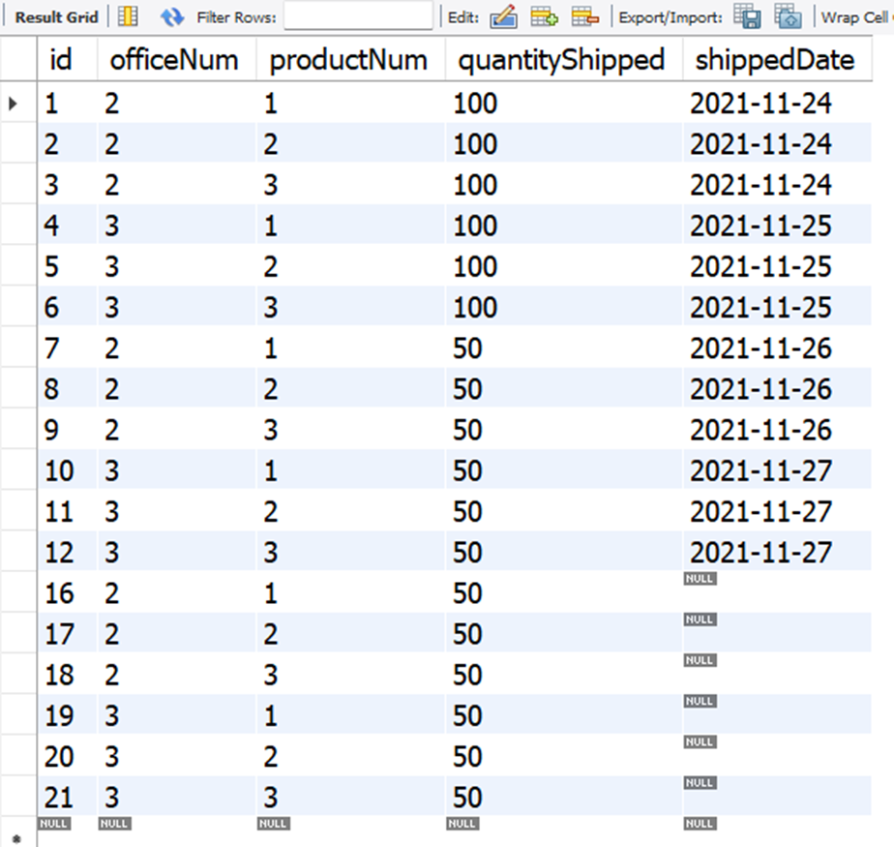

The LineItems table stores the quantity of products that is either in stock at the main warehouse or shipped to a branch (total amount). The Shipped table has the information on the number of products having been shipped to a branch. If a product has been shipped to a branch office, it is no longer at the main office warehouse (shipped amount). Therefore, to find the quantity in stock at the main office warehouse, we subtract the quantity in the LineItems table to the one in the Shipped table (total – shipped).

The query will first find all products that have arrived at the main warehouse (arrivalDate is not null). Next, it will group the products based on the product number. Then, it will find the total quantity of the products in each group.

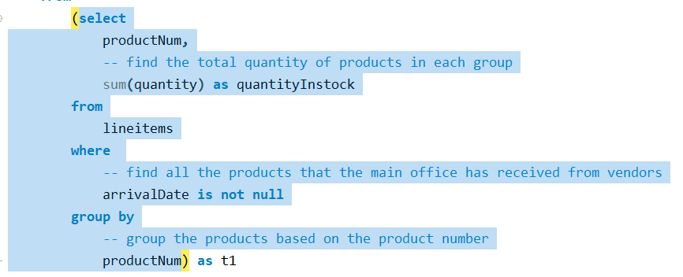

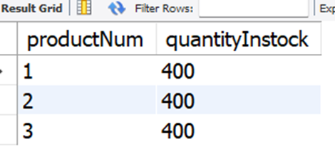

Similarly, it will find all products shipped to all branches, group the products, and then find the total quantity in each group.

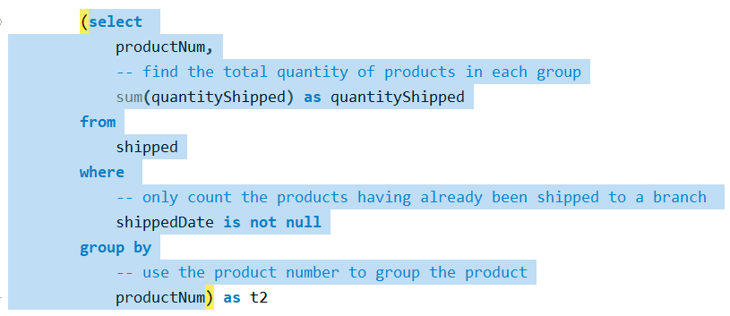

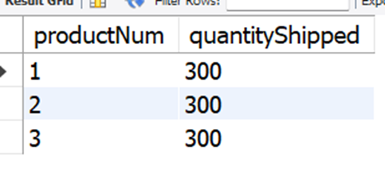

Next, the query will join these two tables to find the remaining quantity in stock at the main office. The product number is used to merge the two tables. After that, find the remaining quantity in each group.

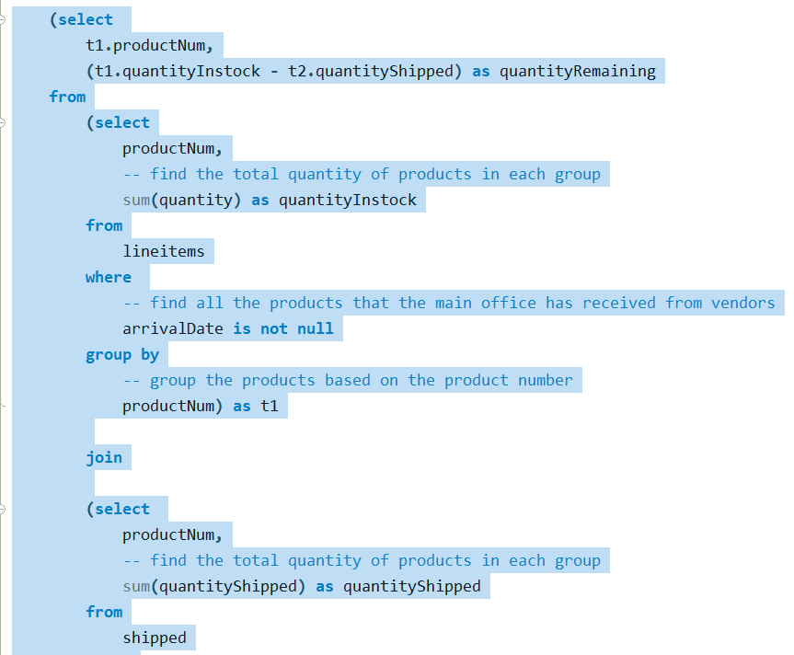

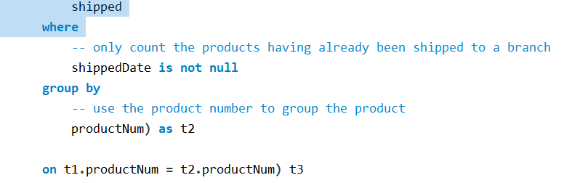

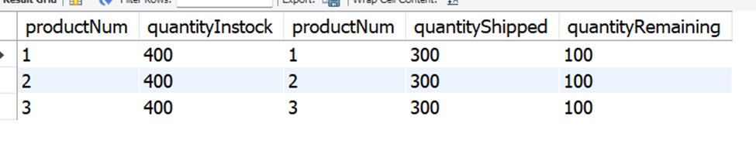

However, the user is only interested in the product name and the quantity remaining. Therefore, the query will remove the irrelevant information from the table above and add other significant information to the final result.

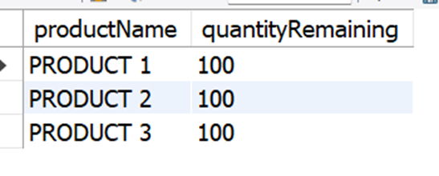

Query :

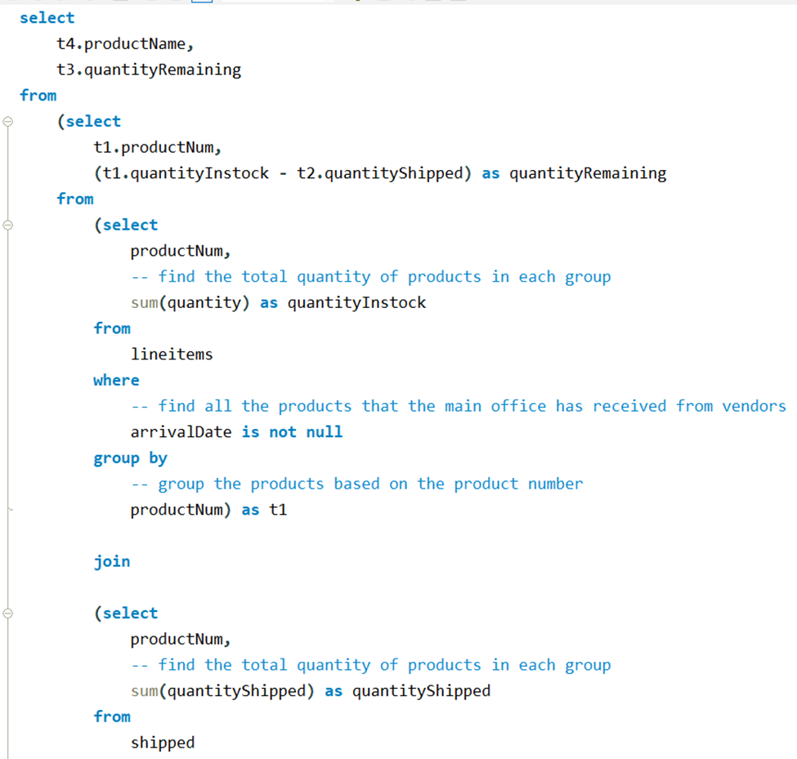

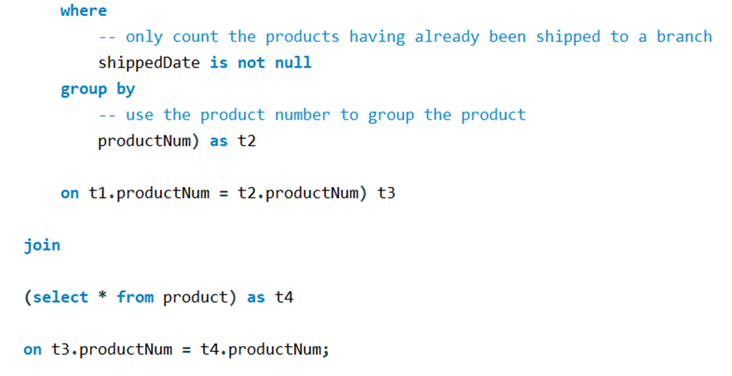

**3rd Complex Query:** generate the weekly orders report for branch offices

The query finds products shipped to a specific branch within the past 7 days, starting today. The result contains products shipped to branch #2.

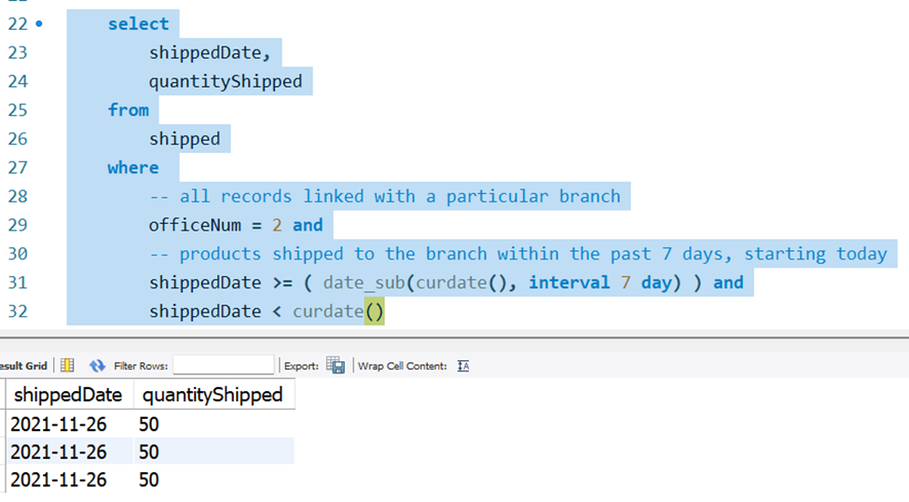

Repeat that, but this time, the lookup condition is looking for products that have not been shipped.

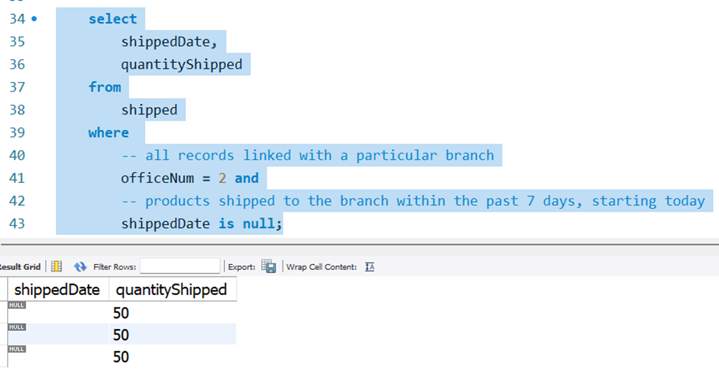

Then combine the two tables to find the weekly orders shipped to a branch.

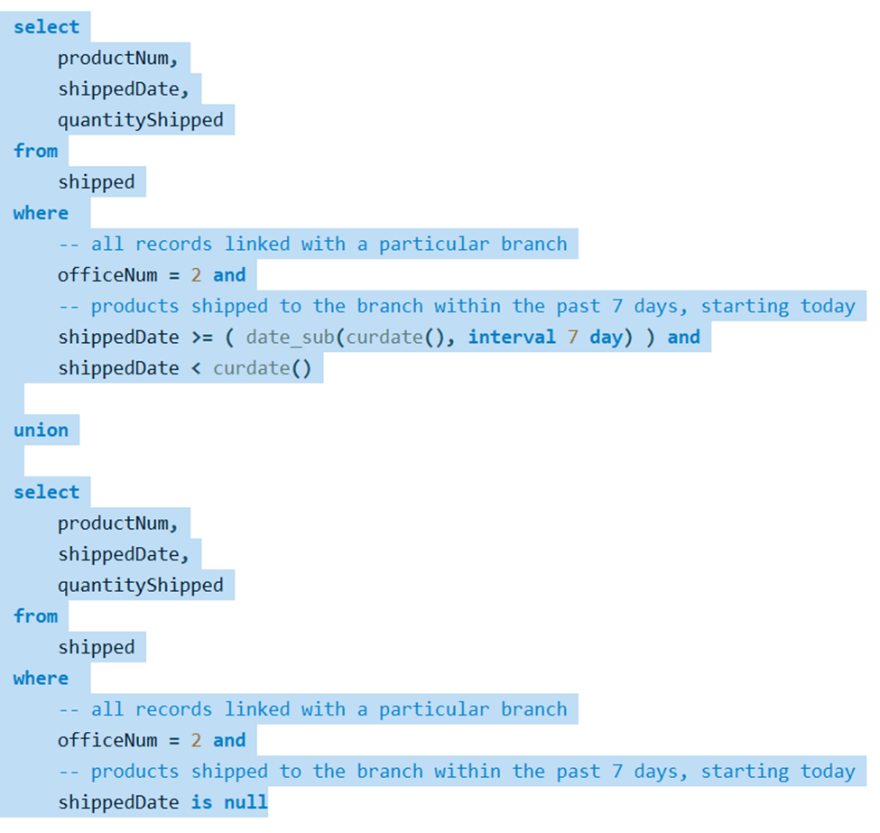

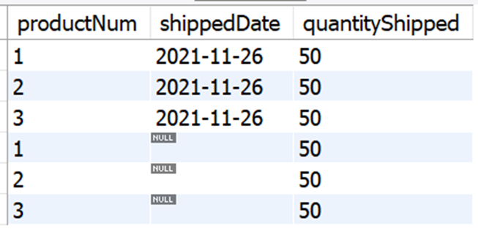

Lastly, join the product table and the above result to get rid of irrelevant information as well as add more information the user is interested in.

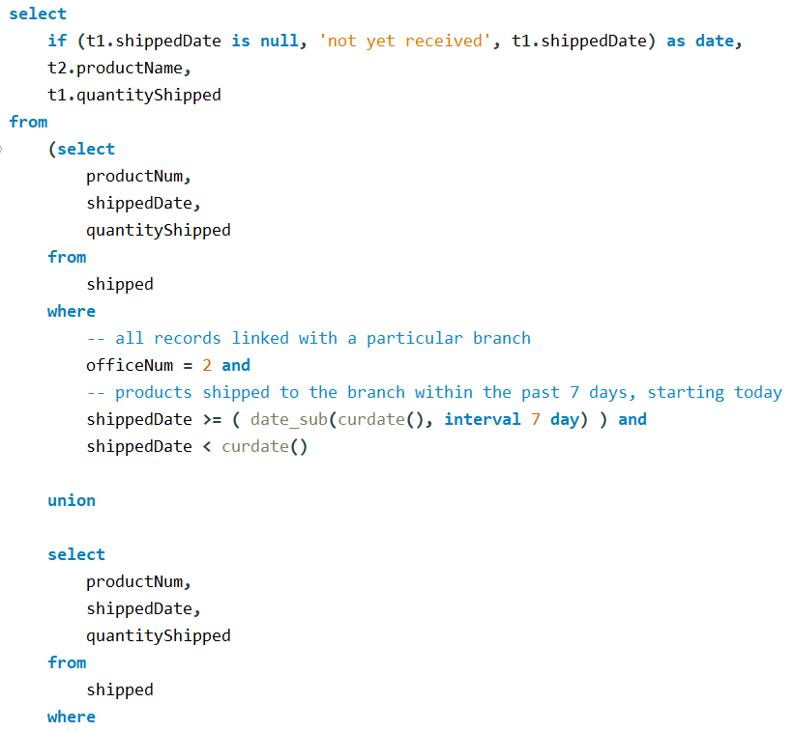

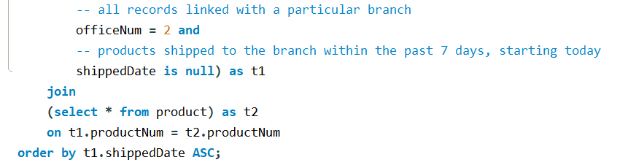

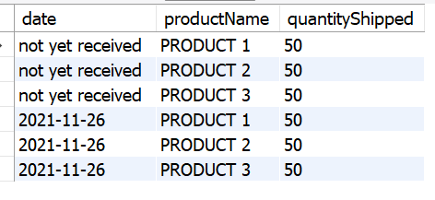

**USER APPLICATION INTERFACE**

Tools Used for this Project:

1. Eclipse Java EE is used for the program/GUI. The reason we choose this IDE is because it has great debugging and code highlighting systems. Additionally, the majority of us are familiar with Java and Eclipse is a great IDE for developing Java applications.
2. MySQL for the DBMS system. MySQL is a well-known and widely used Oracle-backed open source relational database management system.

It has a client-server architecture and can be used in a networked environment. The server program resides on the same physical or virtual system where the database files are stored, and it is responsible for all interactions with the databases. It runs on virtually all platforms, including Linux, UNIX, and Windows. This program was used to create tables, schema, relations, views, and queries. It was connected with Java for the user interface.

1. Java Persistence API or JPA is used to interact with the DBMS system instead of ODBC. The main reason we used JPA is because it supports class or entity generation from the DB, meaning we can use a tool provided by eclipse to create a class with field names that are the same as the attribute names of an entity. JPA works similarly to ODBC, so there should not be any more advantages to use.

**For the functions that involve creating and deleting records from the database, JPA (DB interaction framework as described above) will automatically generate simple insertion and deletion SQL to do those.**

**We only need to provide the required information into the query and the framework will generate an insertion or a deletion query and send it to DBMS for execution.**

**Most of the processing is done on the application side, so there are not many very complex queries for these functions.**

**Log In:** The system first asks for the user’s SSN for identification. This SSN in the example is the SSN for the administrator.

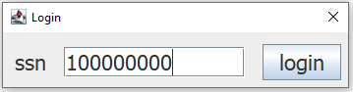

**Main Menu:**

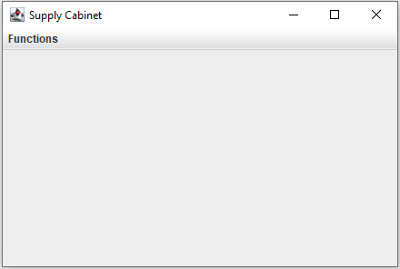

**Main Menu drop downs:** Available functions differ depending on the user’s authority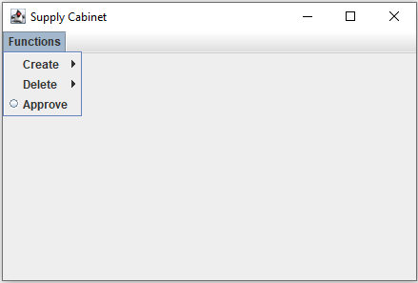

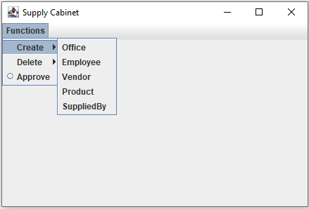

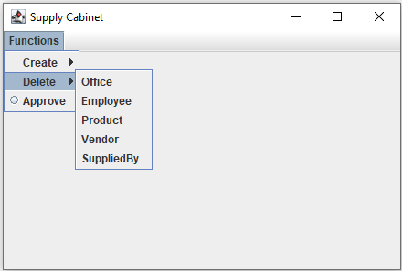

**Create → Office:**

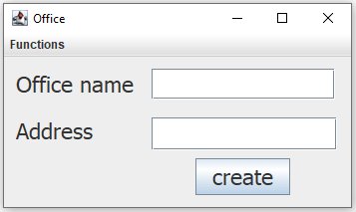

**Create → Office → Create:** Data is created in office table in MySQL

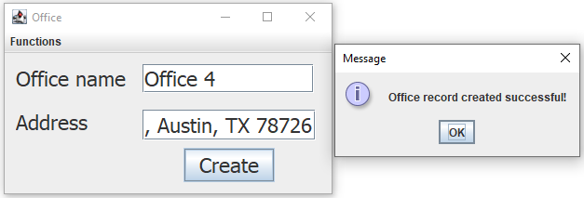

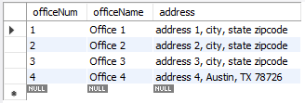

**Create → Office → Create:** With the wrong inputs, it prompts the appropriate error messages to the user

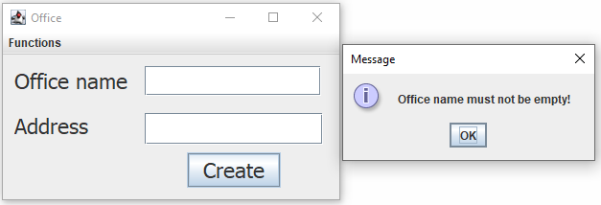

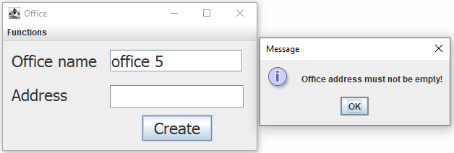

**Create → Employee:**

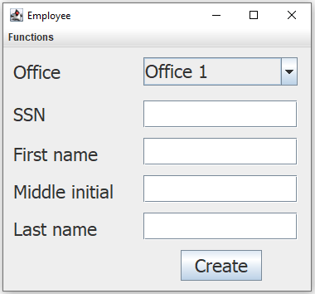

**Create → Employee drop down:**

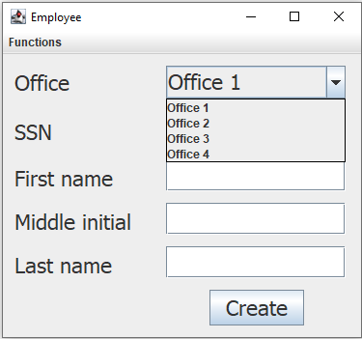

**Create → Employee → Create:** Data is created in employee table in MySQL

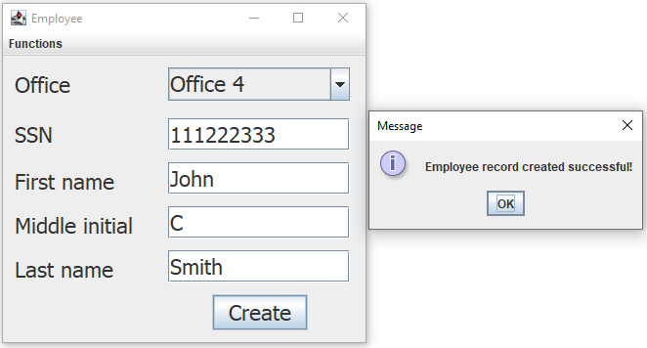

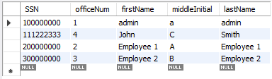

**Create → Employee → Create:** With the wrong inputs, it prompts the appropriate error messages to the user

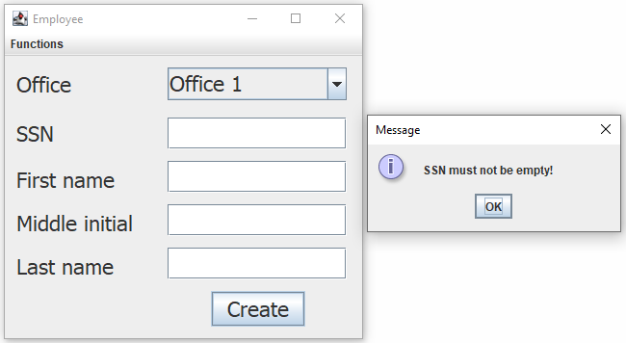

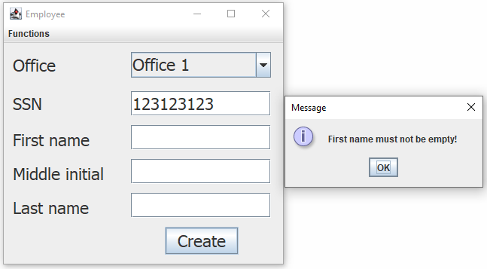

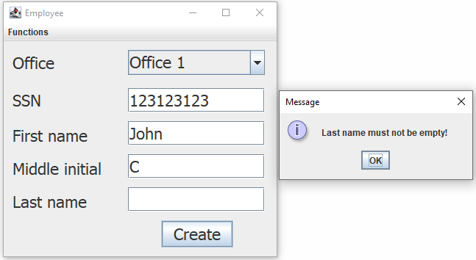

**Create → Vendor:**

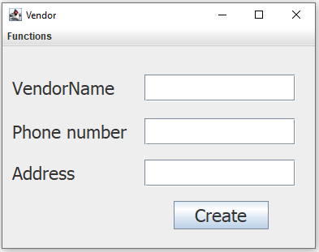

**Create → Vendor → Create:** Data is created in vendor table in MySQL

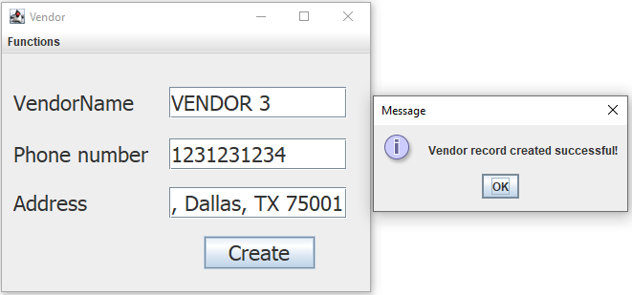

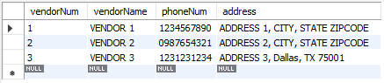

**Create → Vendor → Create:** With the wrong inputs, it prompts the appropriate error messages to the user

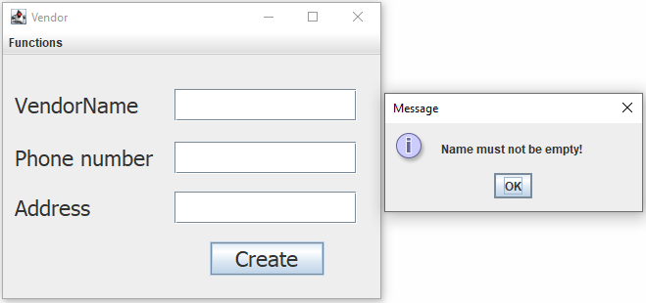

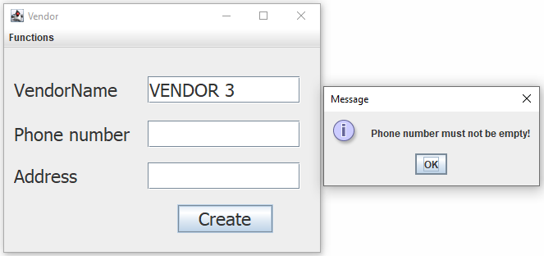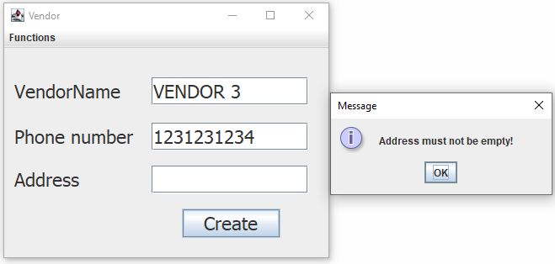

**Create → Product:**

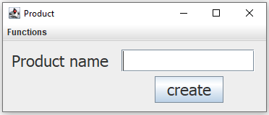

**Create → Product → Create:** Data is created in product table in MySQL

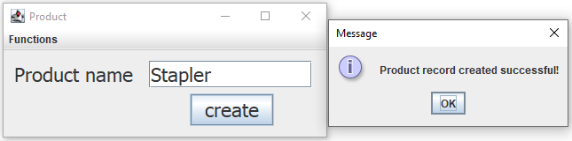

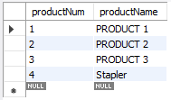

**Create → Product → Create:** With the wrong inputs, it prompts the appropriate error messages to the user

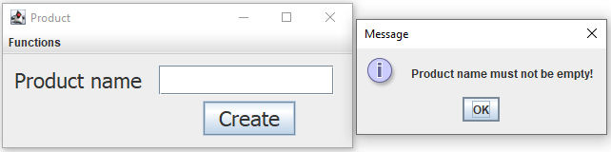

**Create → SuppliedBy:**

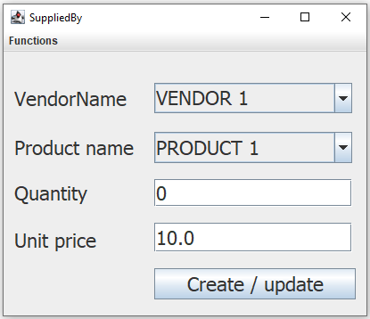

**Create → SuppliedBy drop downs:**

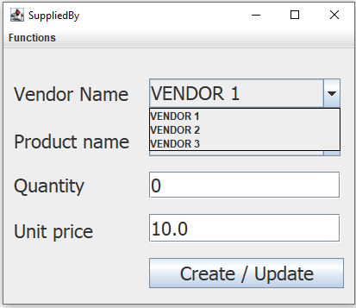

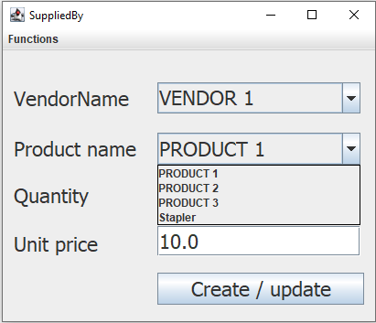

**Create → SuppliedBy → Create / update:** Data is created / updated in suppliedby table in MySQL

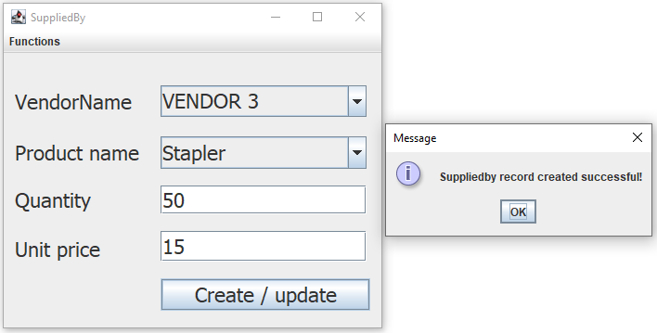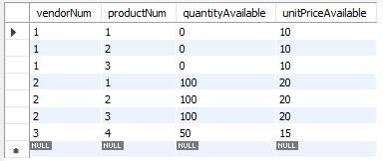

**Create → SuppliedBy → Create / update:** With the wrong inputs, it prompts the appropriate error messages to the user

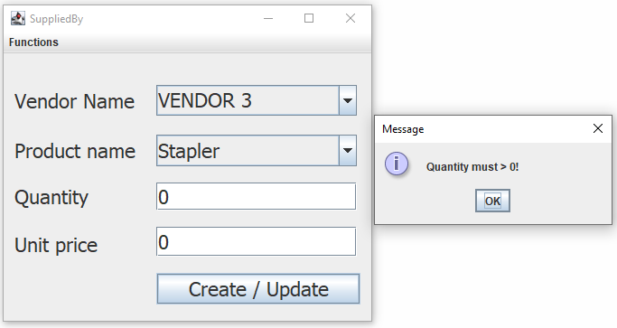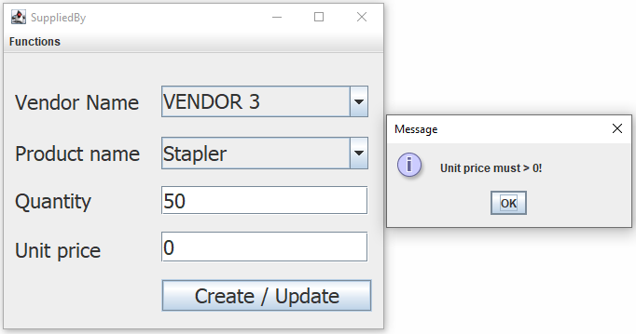

**Delete → Office:**

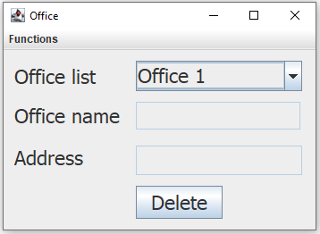

**Delete → Office drop down:**

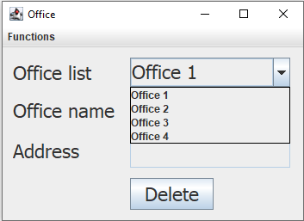

**Delete → Office → Delete:** If the selected office has employees, it prevents the deletion of that office from office table in MySQL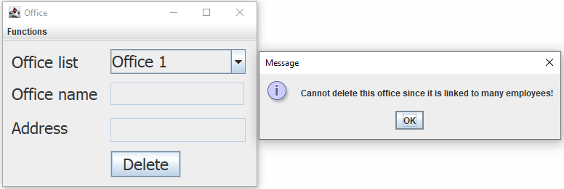

**Delete → Office → Delete:** If the selected office has no employees, the data is deleted from office table in MySQL

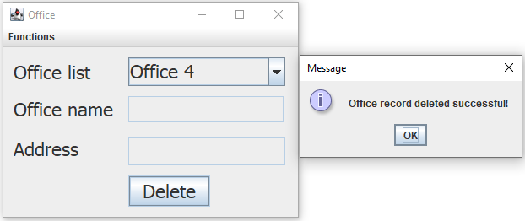

**Delete → Employee:**

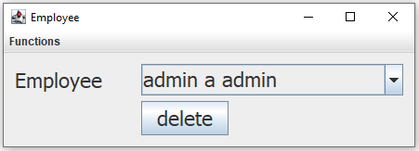

**Delete → Employee drop down:**

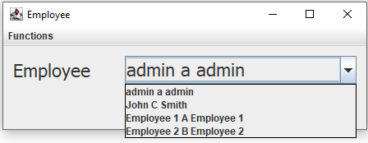

**Delete → Employee → Delete:** If the selected employee has a relation with an existing order, then it prevents the deletion of that employee from employee table in MySQL

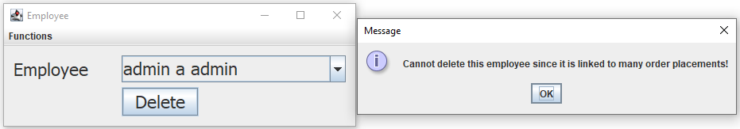

**Delete → Employee → Delete:** Data is deleted from employee table in MySQL

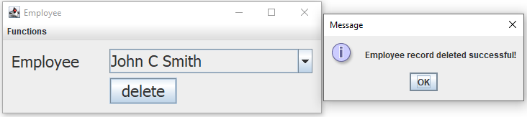

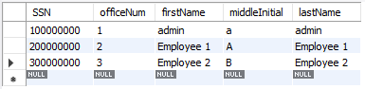

**Delete → Product:**

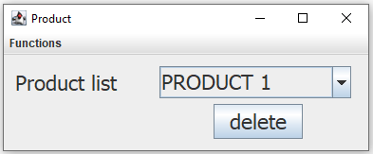

**Delete → Product drop down:**

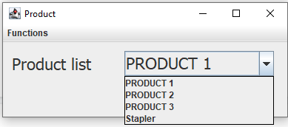

**Delete → Product → Delete:** If the selected product has an association in suppliedby table, then it prevents it from being deleted from product table in MySQL

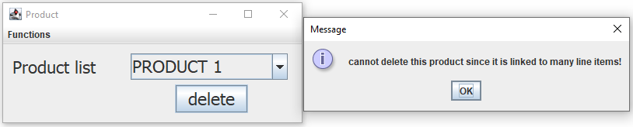

**Delete → Product → Delete:** If the selected product does not have an association in suppliedby table, then it deletes it from product table in MySQL

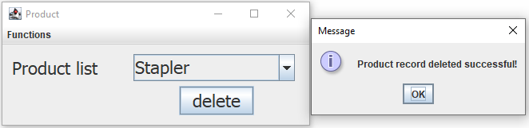

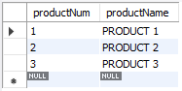

**Delete → Vendor:**

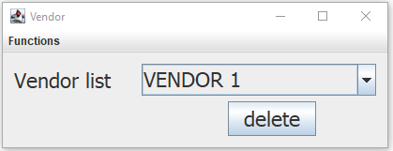

**Delete → Vendor drop down:**

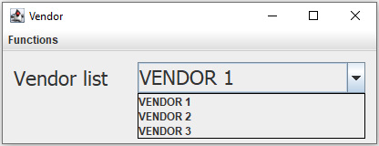

**Delete → Vendor → Delete:** If the selected vendor supplies products that are ordered, then it prevents it from being deleted from vendor table in MySQL

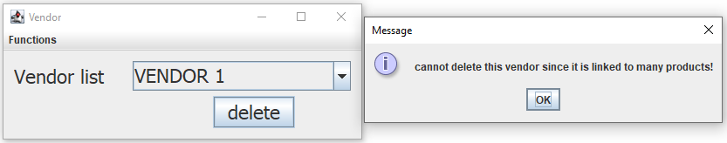

**Delete → Vendor → Delete:** If the selected vendor does not supply any products, then it is deleted from vendor table in MySQL

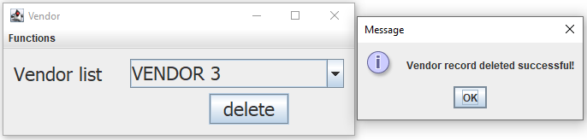

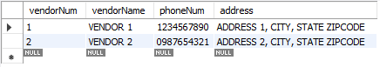

**Delete → SuppliedBy:**

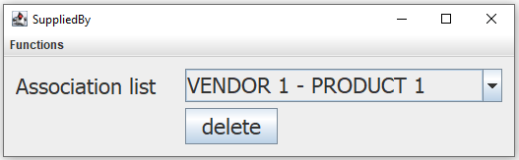

**Delete → SuppliedBy drop down:**

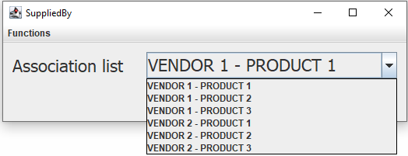

**Delete → SuppliedBy → Delete:** Data is deleted from suppliedby table in MySQL

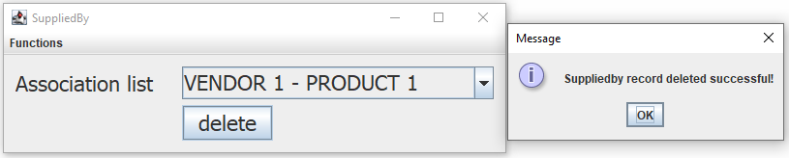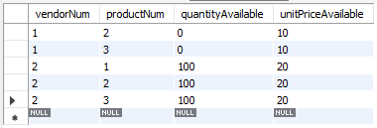

**Approve:** Can review the orders placed by branch offices and approve them.

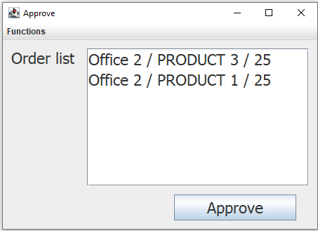

**Approve → Select an order from Order list → Approve:**

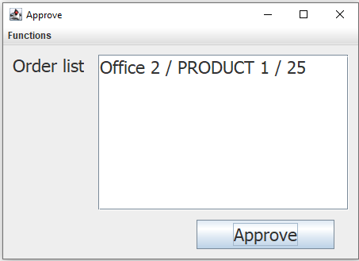

**Order Placement (Main):**

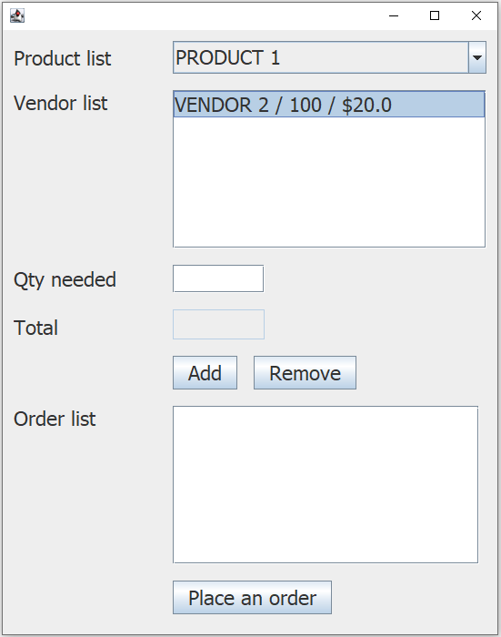

**Order Placement (Main) drop down:**

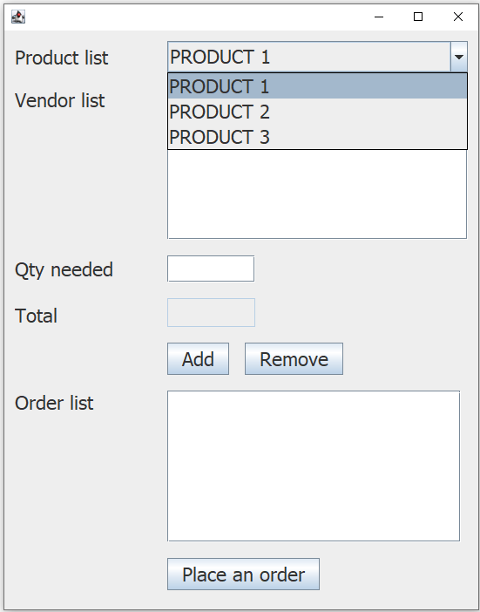

**Order Placement (Main) → Enter quantity needed → Select a vendor:** Gives you the total cost. If you select the vendor without an input in Qty needed, then it prompts the user with an appropriate error message.

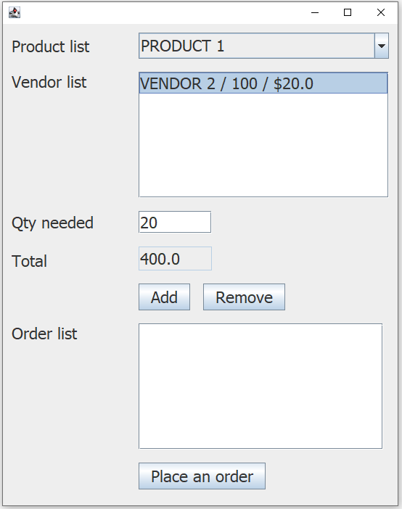

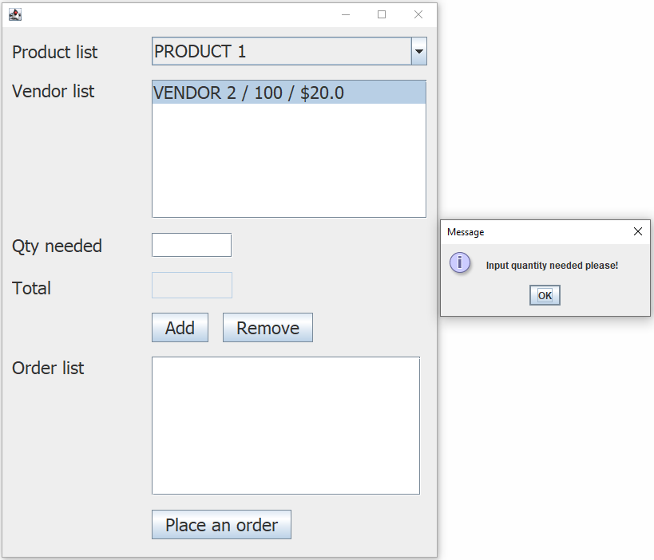

**Order Placement (Main) → Enter quantity needed → Select a vendor → Add:** Deducts the quantity requested from quantity stored. The user can add multiple products.

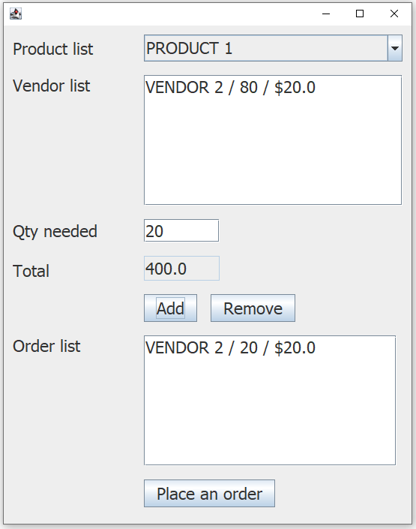

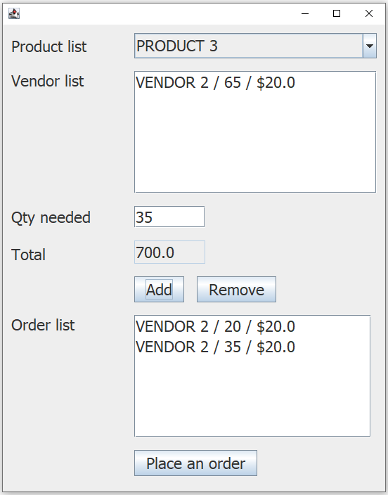

**Order Placement (Main) → Enter quantity needed → Select a vendor → Add → Select an order → Remove:** Removes the selected order and adds the quantity requested back to quantity stored

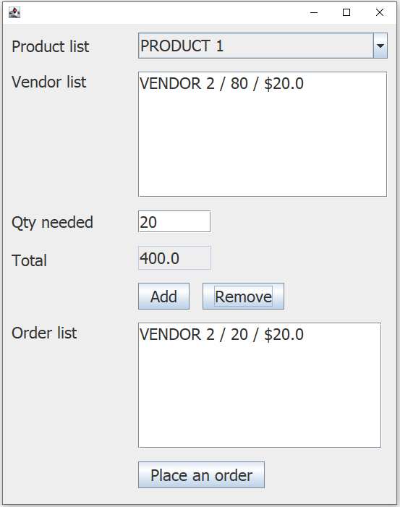

**Order Placement (Main) → Enter quantity needed → Select a vendor → Add → Place an order:**

Places the order and the data is created in orderplacement and lineitems table in MySQL

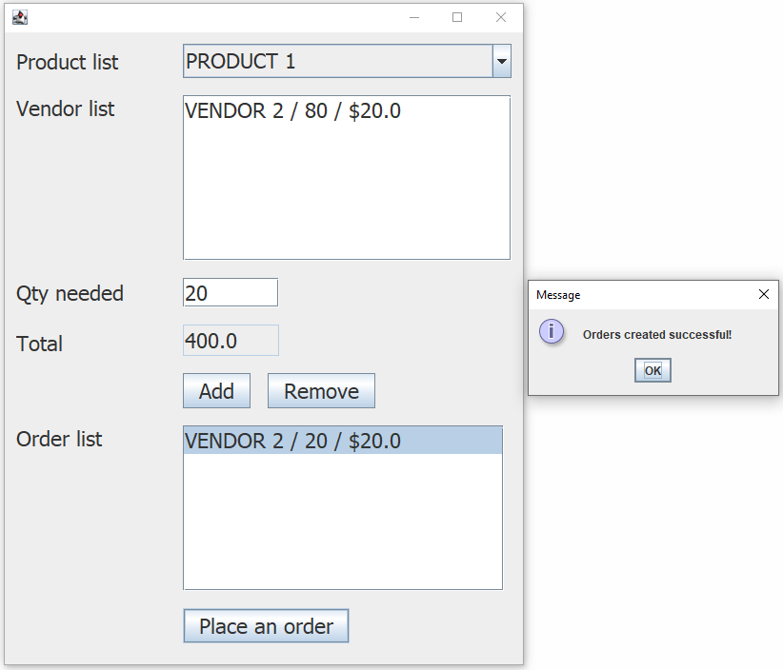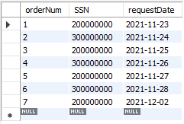

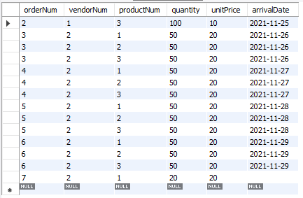

**Order Placement (Branch):**

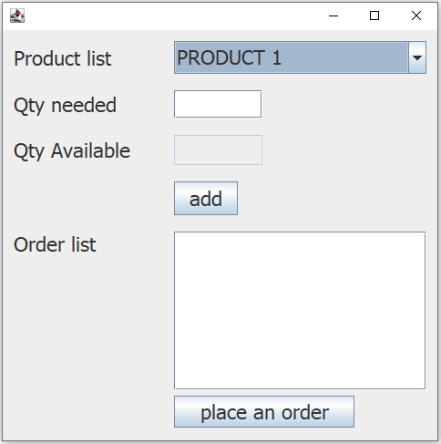

**Order Placement (Branch) drop down:**

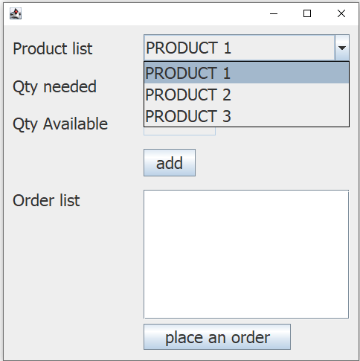

**Order Placement (Branch) → Select the product → Enter quantity needed → Add → Select one of the orders from Order list → Place an order:** Data is created in shipped table in MySQL. The user can add multiple products.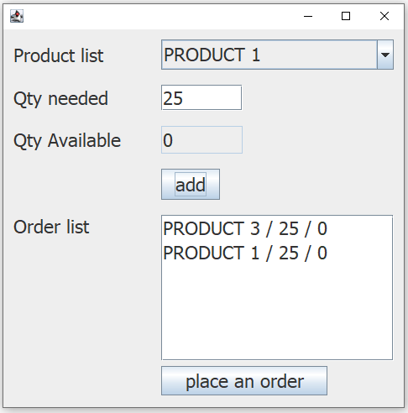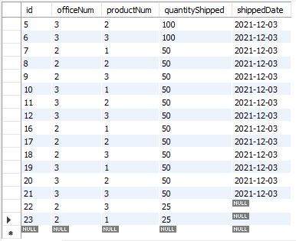

**Branch Office Report:**

Weekly orders show the orders placed within the past week from a certain office. In this example, it shows the orders made from office 2. Products in stock are calculated using shipped and sold tables, the amount of products the office sold within the past week is deducted from the amount of products it received in that week. Products not yet received from the main office show the orders that weren’t shipped yet from the main office using the shipped table.

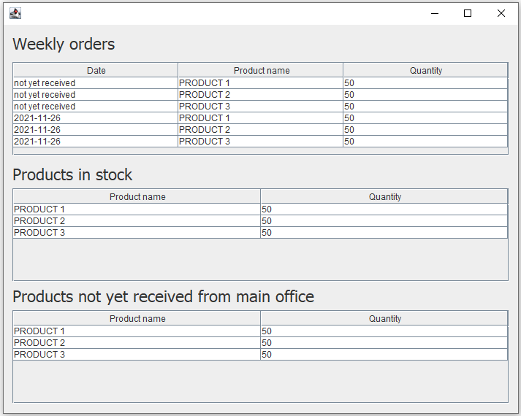

**Main Office Report:**

Weekly orders show the orders placed within the past week from all branch offices. Products shipped to branches use the shipped table to show which products have been shipped to branch offices within the past week. Products still in stock are calculated using lineitems and shipped tables, the amount of products the main office shipped to branch offices within the past week is deducted from the amount of products that are in the main office storage.

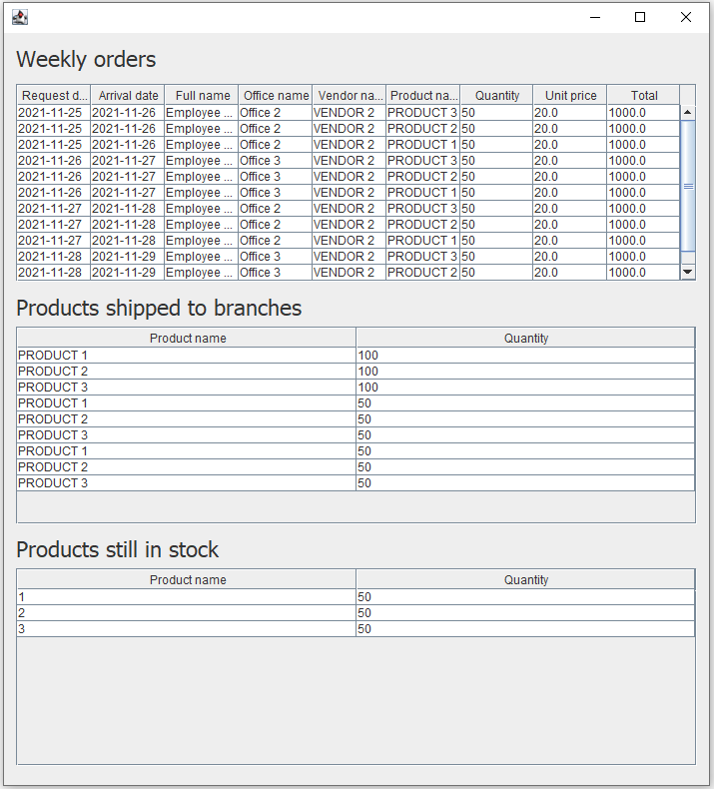

**CONCLUSIONS AND FUTURE WORK**

The purpose of this project was to gain experience with DBMS software, SQL, and database design techniques learned throughout the course. The goal of the project was to create a system that would require the use of entity-relationship modeling, relational database design, SQL, normalization, and web based database system development skills.

To achieve this a system was implemented to provide a centralized location to keep track of all data involving transactions for a company’s supply cabinet. The final system involves a main office, vendors, branch offices, and administrator data along with the corresponding to manipulate said data. The final system also provides an interface where privileged and non privileged functions are carried out by different users, reports are generated, and the data can be seen in different views.

There are several possible ways to continue the development of the supply cabinet system. One possible future improvement would be to add to the supported views of the system; additional views make data interpretation much clearer and could aid in user readability of the system. Similarly, it might also be helpful to refine the user interface so that users are more easily able to identify which functions they want to carry out.

**REFERENCES**

[1] “Accessing Data with MySQL,” *Spring*. [Online]. Available: https://spring.io/guides/gs/accessing-data-mysql/. [Accessed: 28-Nov-2021].

[2] “Adding Items to a JComboBox,” *Stack Overflow*. [Online]. Available: https://stackoverflow.com/questions/17887927/adding-items-to-a-jcombobox. [Accessed: 29-Nov-2021].

[3] G. Wu, “Calling Stored Procedures from Spring Data JPA Repositories,” *Baeldung*, 29-Jul-2020. [Online]. Available: https://www.baeldung.com/spring-data-jpa-stored-procedures. [Accessed: 26-Nov-2021].

[4] “How to Add Row in JTable?,” *Stack Overflow*. [Online]. Available: https://stackoverflow.com/questions/3549206/how-to-add-row-in-jtable. [Accessed: 30-Nov-2021].

[5] “JDBC ODBC Driver Connection,” *Stack Overflow*. [Online]. Available: https://stackoverflow.com/questions/19709843/jdbc-odbc-driver-connection. [Accessed: 25-Nov-2021].

[6] T. Janssen, “Native Queries With Spring Data JPA,” *Thorben Janssen*. [Online]. Available: https://thorben-janssen.com/native-queries-with-spring-data-jpa/. [Accessed: 01-Dec-2021].